A PROJECT REPORT ON

# CDAC APP

### A Student Management Portal

SUBMITTED IN PARTIAL FULFILLMENT OF

#### DIPLOMA IN ADVANCED COMPUTING (PG-DAC)

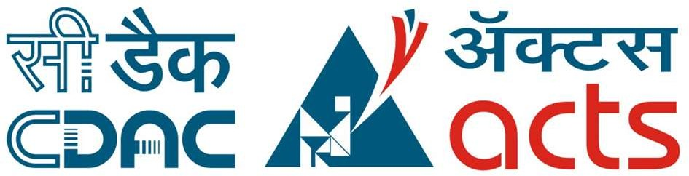

UNDER THE GUIDANCE OF

Mr. Shakir Hussain

PRESENTED BY

|  |  |
| --- | --- |
| 220340120083 | Hardik Agarwal |
| 220340120092 | Joy Pahari |
| 220340120097 | Kamana Mathur |
| 220340120100  220340120120 | Keskar Udit Mahesh  Mayank Sachan |

AT

CENTER FOR DEVELOPMENT OF ADVANCED COMPUTING C-DAC, PUNE

# ACKNOWLEDGEMENT

The project “CDAC APP” was a great learning experience for us and we are submitting this work to Advanced Computing Training School (C-DAC ACTS, Pune).

We are very glad to mention the name of Mr. Shakir Hussain for his valuable guidance to work on this project.

We are highly grateful to Ms. Risha P. R., Manager of ACTS Training Centre, CDAC, for her guidance and support whenever necessary during the course of our journey to acquire PG-Diploma in Advanced Computing (PG-DAC) through CDAC ACTS, Pune.

Our heartfelt thanks go to Ms. Shilpi Shalini (Course Coordinator, PG-DAC) who gave us all the required support and kind coordination to provide all the necessities to complete the project and throughout the course up to the last day of the course.

We would like to express our sincere gratitude towards Mrs. Madhura Anturkar, our faculty for Core Java and Advanced Java, who was always there for us. Her guidance and support helped us overcome various obstacles and intricacies during the course of our project work. Without her tremendous support, guidance, and efforts, this project would not have been possible.

From:

|  |  |
| --- | --- |
| Hardik Agarwal | 220340120083 |
| Joy Pahari | 220340120092 |
| Kamana Mathur | 220340120097 |
| Keskar Udit Mahesh  Mayank Sachan | 220340120100  220340120120 |

ABSTRACT

1.

INTRODUCTION

2.

PROJECT OVERVIEW AND SUMMARY

# TABLE OF CONTENTS

#### Purpose

* 1. Scope

#### Overview

* 1. Feasibility Study

3. REQUIREMENTS FULFILLED

#### Functional Requirements

* 1. Non-Functional Requirements

4. PROJECT DESIGN

#### Data Model

* 1. Functional Decomposition Diagram

#### Use Case Diagram

* 1. Activity Diagram

#### Project Architecture

* 1. ER Diagram

6.

TESTING

7.

CONCLUSION

8.

FUTURE SCOPE

9.

REFERENCES

5. PROJECT SCREENSHOTS

#### Student

* 1. Admin

# ABSTRACT

CDAC has been a major part on our career paths. It offered us courses in Online Mode due to Covid-19 situation. It was so convenient for students to attend the entire course and perform all its related activities sitting at their place. Due to this Online Mode, there was neither time consumption in travelling nor the risk of getting infected by other people. Understanding the need of the hour, this project is useful for courses that can be conducted in Online Mode in CDAC ACTS, Pune. This portal allows efficient student management at the comfort of our homes.

In our project, we aim to provide a portal for managing all the students which are admitted into CDAC ACTS for various online PG Diploma Courses wherein they can login to the portal and use it throughout the course.

# INTRODUCTION

Centre for Development of Advanced Computing (C-DAC) is the premier R&D organization of the Ministry of Electronics and Information Technology (MeitY) for carrying out R&D in IT, Electronics and associated areas. Different areas of C-DAC, had originated at different times, many of which came out as a result of identification of opportunities.

C-DAC has today emerged as a premier R&D organization in IT&E (Information Technologies and Electronics) in the country working on strengthening national technological capabilities in the context of global developments in the field and responding to change in the market need in selected foundation areas.

C-DAC's Education and Training programmes are aimed at creating skilled manpower in the country by providing quality training programmes in the field of Electronics and ICT. This activity started almost two decades ago with a humble beginning of training about 20 students per year, but has today grown to an extent of training more than 5000 students per year. It also grew from just one training center to about 50 training centers across India and has even made its presence in several countries abroad.

In addition to conducting wide range of training programmes in the areas of Information, Communication and Electronics technologies, C-DAC also develops ICT tools and technologies for modern methods of imparting education and training to masses.

From a student point of view, the students can browse through the portal, give MCQ exams, see their results, performance, find the schedule and get the attendance report, provide feedback to faculties.

From an admin point of view, the admins can generate PRN, provide MCQ papers, collect feedback from students, set notice on dashboard etc.

# PROJECT OVERVIEW AND

SUMMARY

## PURPOSE

Our project, “CDAC APP”, is a web-based online student management portal which aims to provide admin with functionalities to manage students in PG Diploma courses of CDAC ACTS Pune, efficiently.

## SCOPE

“CDAC APP” aims to deliver a web-based portal that manages all the students admitted in the Online PG Diploma courses of CDAC ACTS Pune where Course-Coordinator is the Admin. Students can update their profile, get schedule, join lectures and their respective labs, write module-wise MCQ tests, get the results and also give their feedback for each faculty. Admins can generate PRN for registered students, upload exam papers, set results, get feedback list, etc. They also can upload links for lectures and labs as well as set notice.

We are assuming that the organization that implements it will be using third-party platform where lectures are conducted. Also, an API which can easily be integrated in our application can be created in future if needed. CDAC APP is a portal for both students (for course related activities) and admins (for managing students).

## OVERVIEW

### A.TECHNOLOGIES USED

#### FRONT END

* + HTML
  + CSS
  + Bootstrap
  + JavaScript
  + Ajax
  + JQuery

#### BACK END

* + Spring MVC
  + Spring Boot
  + Spring Data JPA
  + Spring Security
  + Java Mail API

#### DATABASE MANAGEMENT SYSTEM

* + MySQL

### B. FEATURES PROVIDED

#### FOR STUDENTS

* + 1. Register – Students can register themselves if they have appeared for CCAT entrance exam for PG Diploma courses and have valid CCAT number.
    2. Login – Successfully registered candidates receive confirmation Email from CDAC and are now eligible to Login. They receive PRN to Login into the portal. For first time login, username and default password both are PRN.
    3. View and Update Profile – After successful login, students can view and update their profile and password.
    4. Join Link – Students can join lectures and labs using the links provided under the Join Link dropdown in navigation bar.
    5. Exam – Students can give module-wise MCQ exam on the portal itself.
    6. Result – Students get the result of MCQ test module-wise.
    7. Give Feedback – Students can give feedback for faculties based on provided criteria.
    8. Logout – After utilizing the portal, students can Logout of the portal.

#### FOR ADMINS

* + 1. Login & Logout – Similar to students, admins can login & logout to access their account.
    2. Generate PRN – For successfully registered students, admin generates PRN which student will carry till the course end as their identities. This PRN is students’ username and default password.
    3. Upload Attendance – Admin will upload students’ attendance.
    4. Upload Question Paper – Admin will upload Question Paper for MCQ test for students.
    5. Set Result – Admin will set result for students which students can access through the portal when they login.
    6. Feedback List – Admin will receive the list of feedbacks provided by students.
    7. Upload Link – Lecture and Lab Links are uploaded in the given section in the navigation bar.
    8. Upload and Update Notice – Admin will be able to upload and update notice on floating notice board.

## FEASIBILITY STUDY

Feasibility is the determination of whether a project is worth undertaking or not. Before actually recommending the new system, it is important to investigate if it is feasible to develop it.

Before developing and implementing a system, we have to make sure that the system is feasible in the following ways:

### A. TECHNICAL FEASIBILITY

In this type of feasibility study, the system analyst has to check whether it is possible or not to develop the requested system with the available manpower, software, hardware, etc.

This project makes use of cross-platform software and solutions like Java, and hence can run on any operating system. JavaScript, used in front-end, is swift and versatile framework when it comes to delivering the requested page. Also, as JavaScript is popular, it is easy to learn it and utilizing it as front end technology. The combination of Spring Boot, Spring Data JPA and Spring Security for backend make for a fast, easy to set-up and reliable system to interact with the database, as they are secure and transactional in nature. Since the sensitive data of customers and admins need to be stored in a robust and secure database, MySQL database management system was chosen as it is an industry standard.

### B. OPERATIONAL FEASIBILITY

In this type of feasibility study, the operation of the system is considered. An analysis is performed on whether it is feasible for the user department to use the application. Thus, the proposed system is said to be operationally feasible only if clients are able to understand the system clearly and correctly, and can use it with ease.

In the design of this project, we always kept user experience in mind. We made an effort to have a good user interface with consistent theme and alluring design to keep the users interested and engaged. In our project, the use of universally known icons and instructions that are easy to understand makes sure that the user will not need any special technical know-how to use the application. We made sure that the information available throughout the application is arranged in a logically coherent and consistent manner, guaranteeing that the users will have a smooth and effortless experience and even enjoy using the application.

### C. ECONOMIC FEASIBILITY

In this type of feasibility study, the benefits of the system to the organization are considered by taking into consideration the cost-benefit analysis. All the software and technologies used in our project free, open-source, and widely available, with each of the technologies having an extensive community support. This makes “CDAC APP” an economically feasible solution to the organizations that wish to implement it.

# 

# 3. REQUIREMENTS FULFILLED

## FUNCTIONAL REQUIREMENTS

Following are the functional requirements fulfilled by our project:

* Students can register themselves if they have appeared for CCAT entrance exam for PG Diploma courses and have valid CCAT number.
* Further, they are asked to fill in their personal details and address details.
* Once all students are registered, they get a confirmation Email from CDAC for successful registration.
* Admin generates PRNs for successfully registered students.
* Students can login for the first time with username and default password as their own PRN.
* Students now can edit their profile, change password and use all the functionalities effectively.
* Admins can update Notice Board, Schedule, Exam papers, etc.
* Admins can get the results and faculty feedbacks from students, too.

## NON-FUNCTIONAL REQUIREMENTS

Following are the non-functional requirements fulfilled by our project:

* Since the application uses lightweight and established software components that are also cross-platform, it is remarkably performant and has good support for every operating system.
* The use of JavaScript and JQuery for front end and Spring Boot, Spring Data JPA and Spring Security for back end delivers quick response times to admins and students.
* Card-style UI and well-known icons and symbols used throughout the application provides a consistent theme and user-friendly interface that anyone can grasp easily, even without a technical background.

# PROJECT DESIGN

## DATA MODEL

The following tables depict the database design used for “Wordsworth” application:

### Tables Related to User Details

#### Users Table

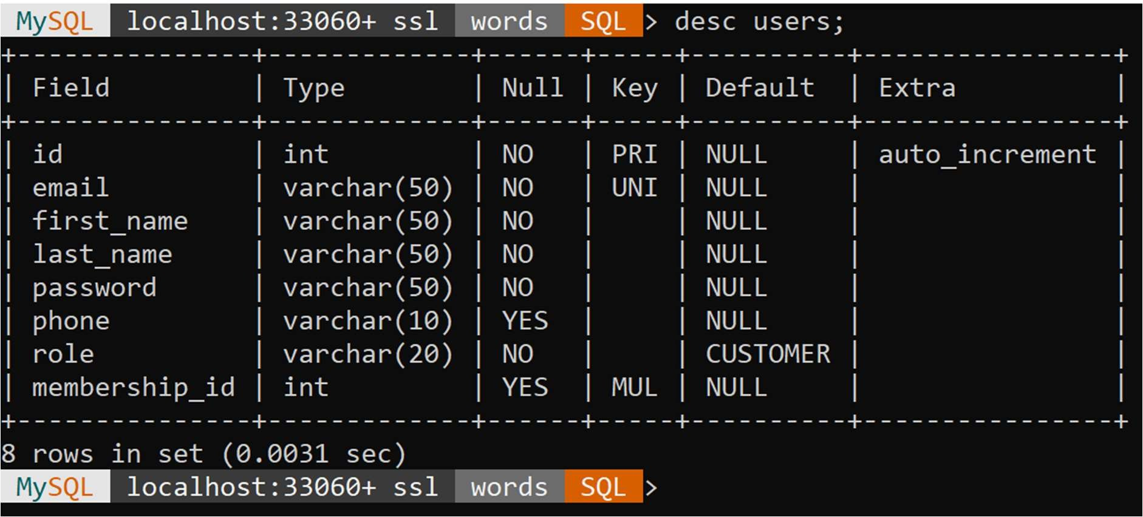

* + - 1. Memberships Table

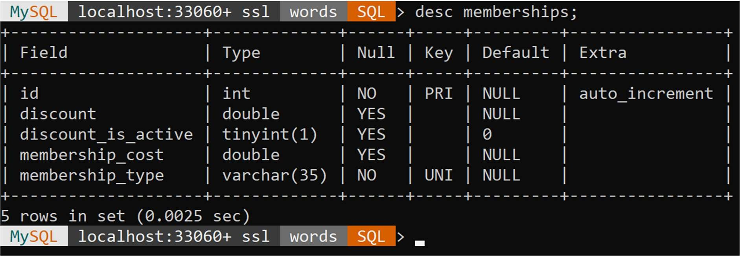

#### Addresses Table

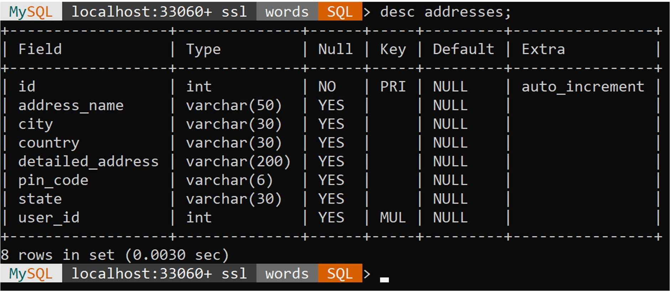

* + - 1. Cards Table

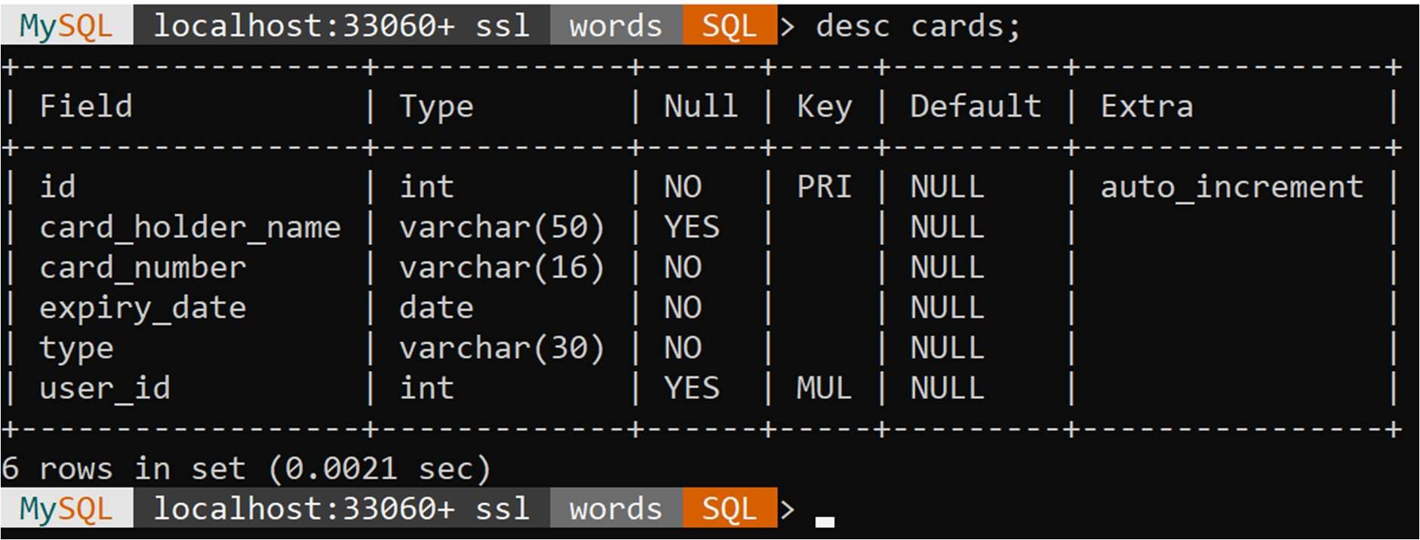

#### Tables Related to Orders

* + - 1. Cart Items Table

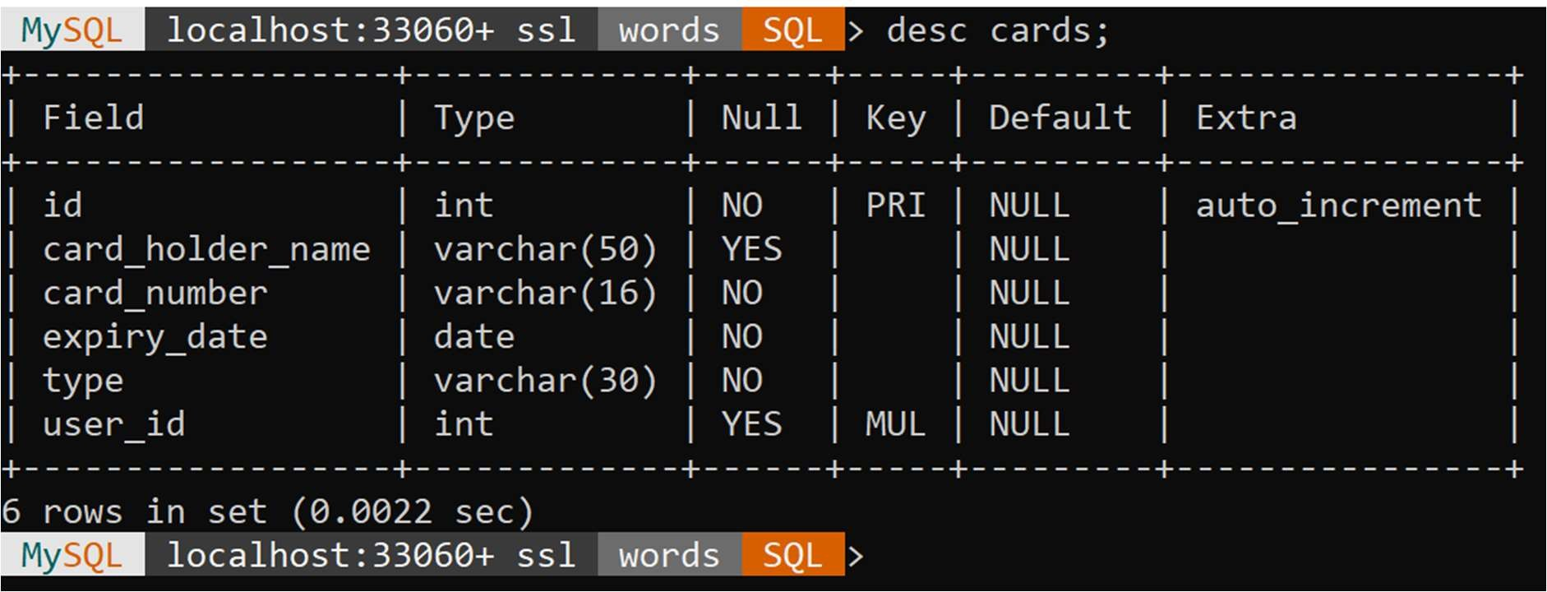

#### Orders Table

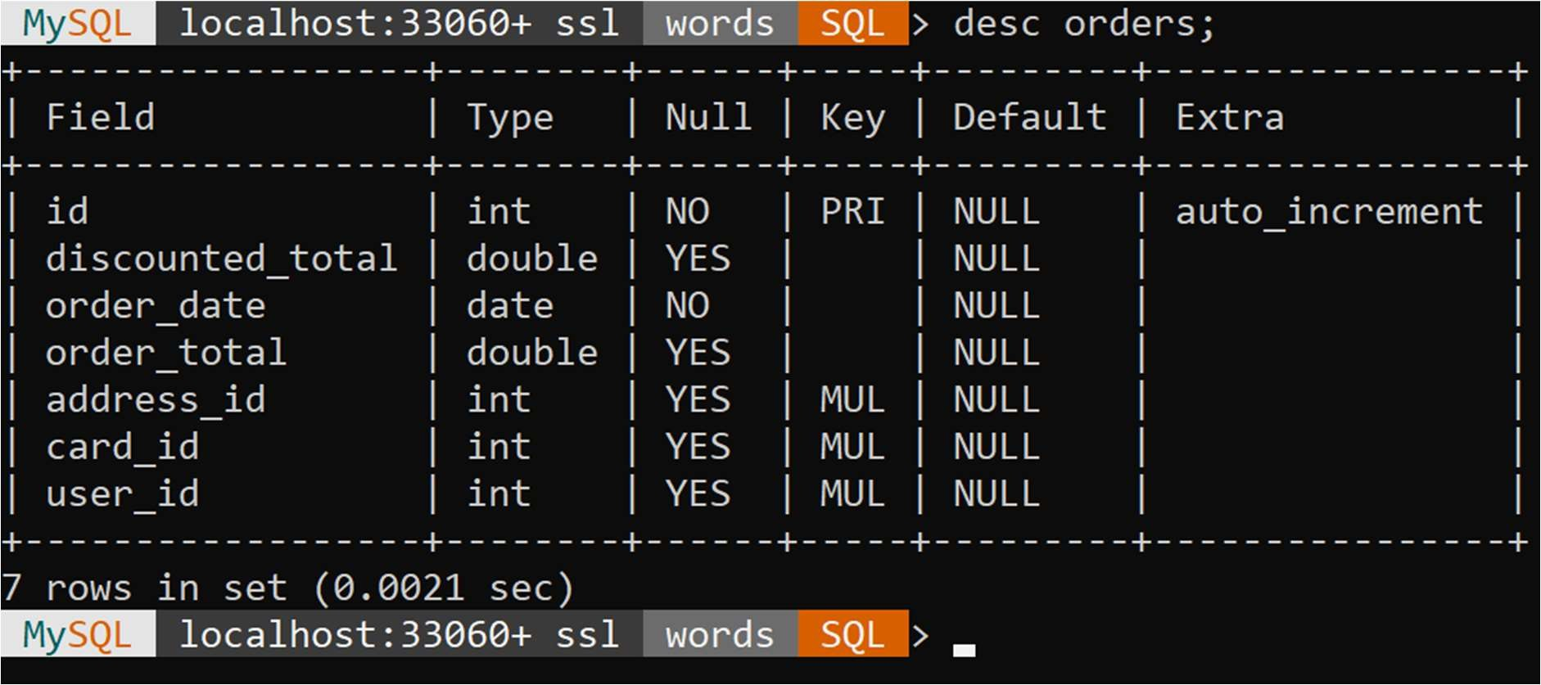

* + - 1. Order Details Table

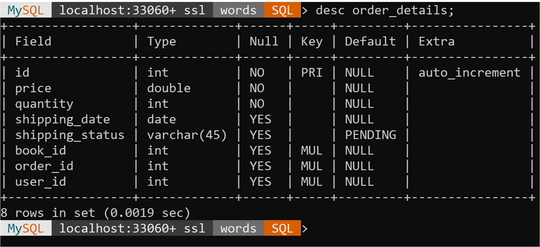

#### Tables Related to Books

* + - 1. Books Table

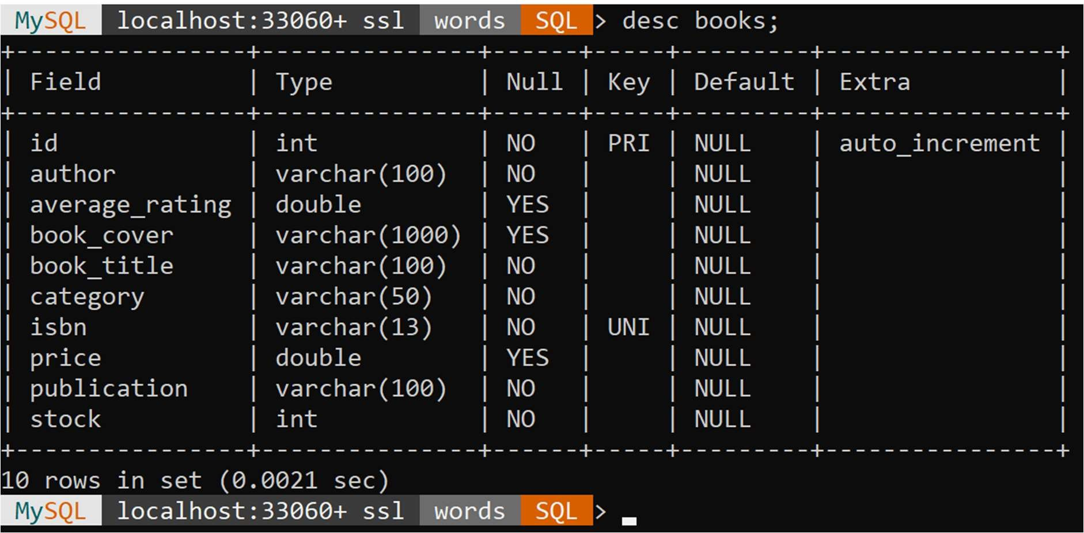

* + - 1. Feedbacks Table

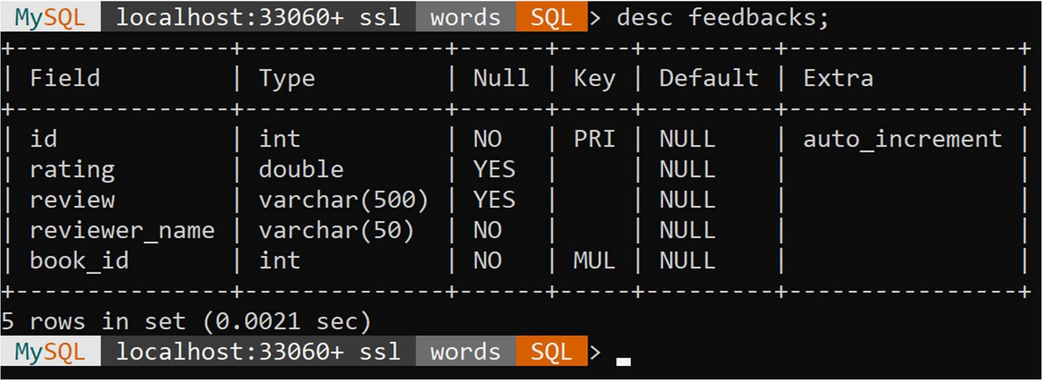

## FUNCTIONAL DECOMPOSITION DIAGRAM

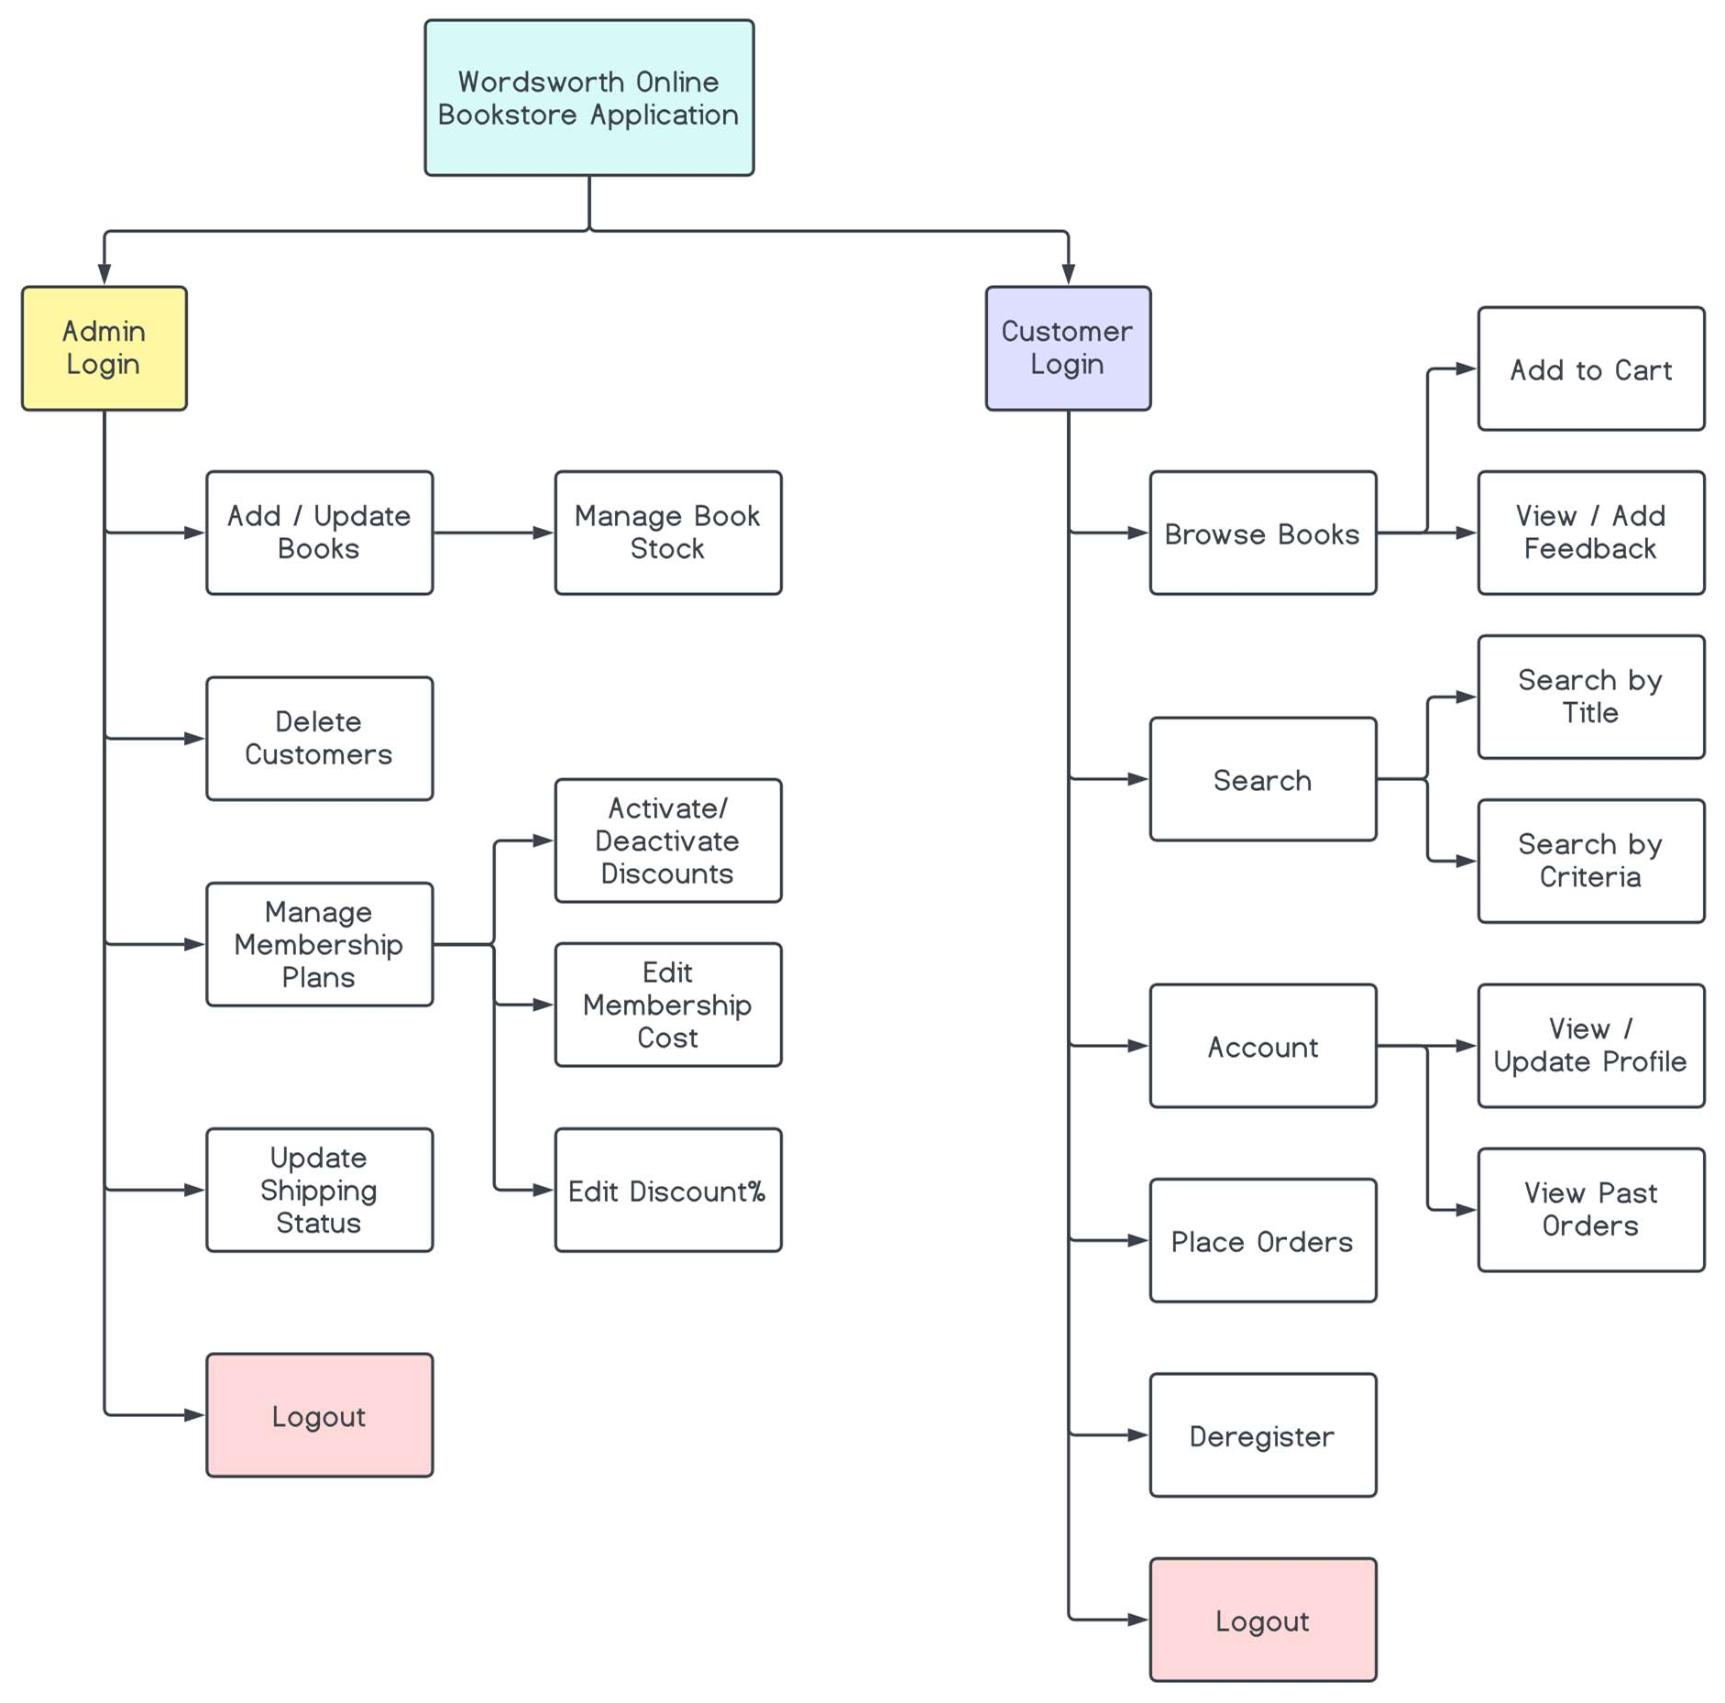

* 1. USE CASE DIAGRAM

## Customer

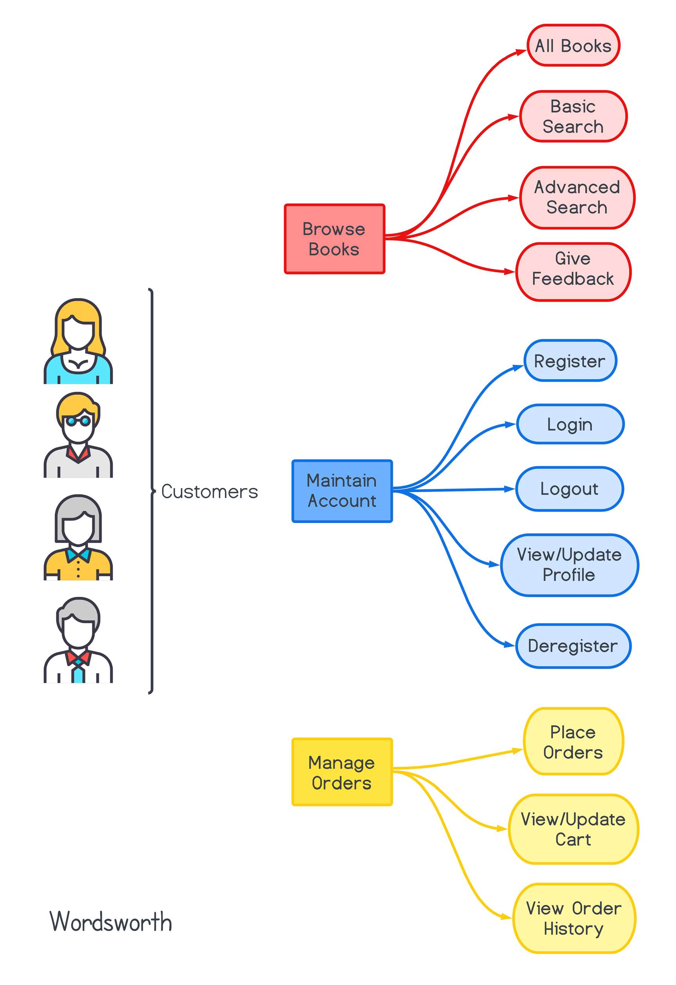

* + 1. Admin

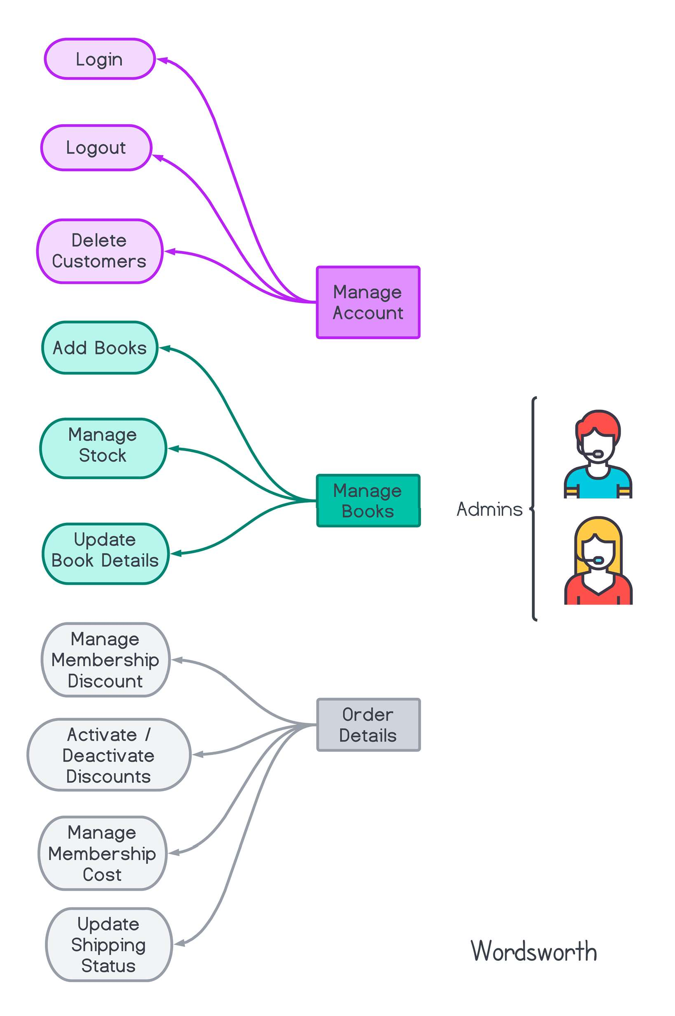

## ACTIVITY DIAGRAM

* + 1. Customer

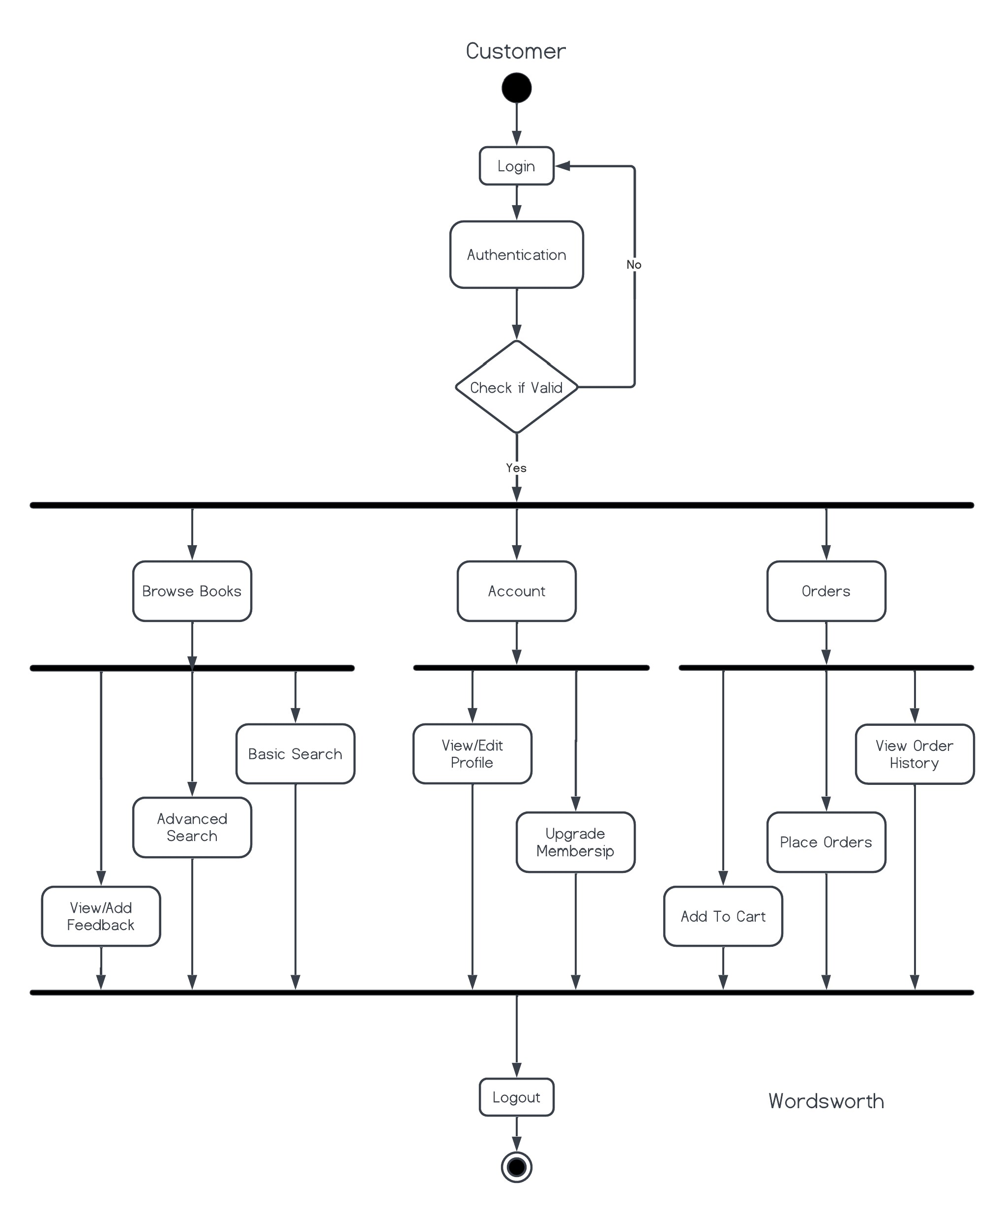

## Admin

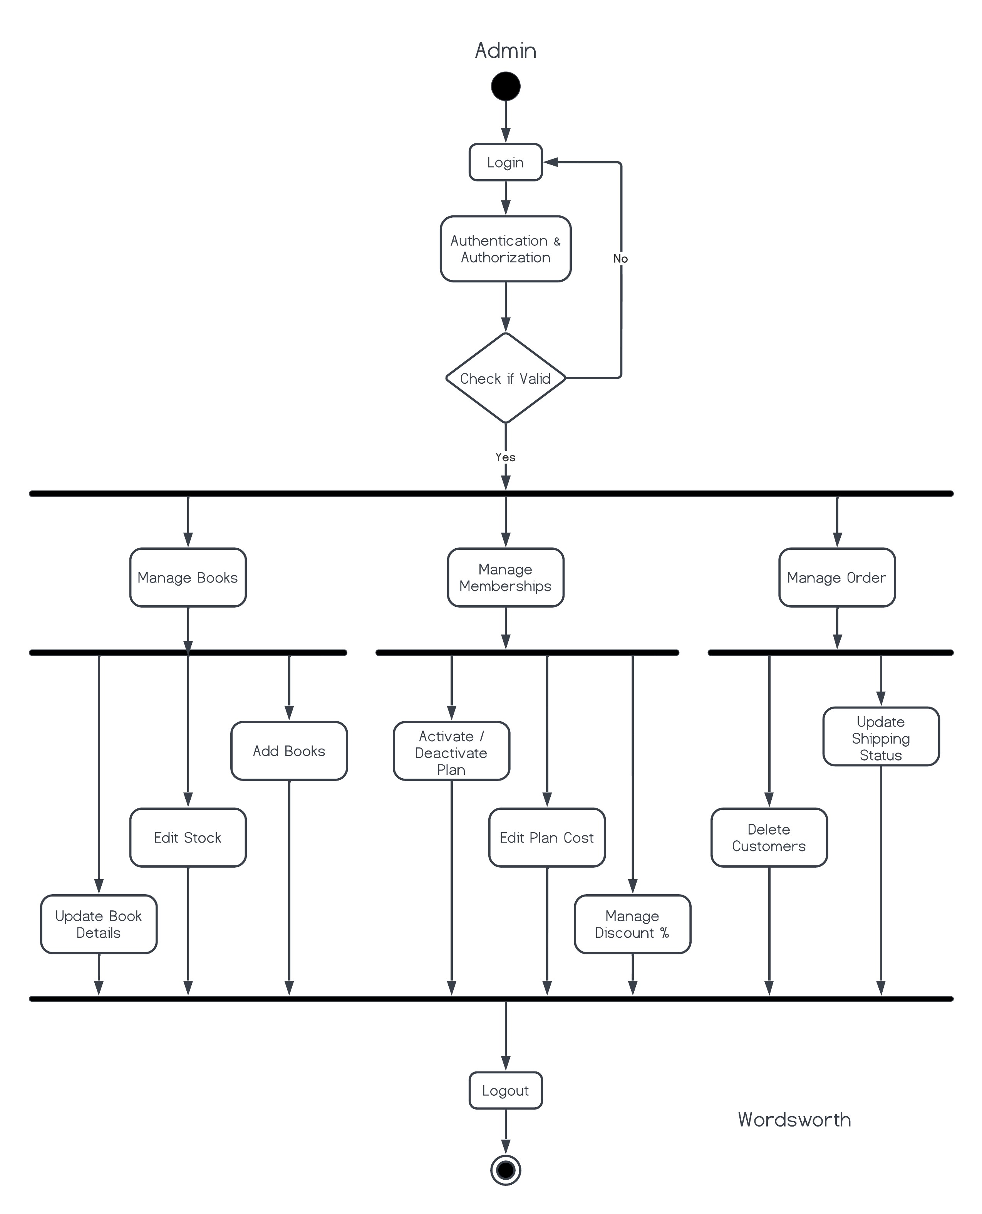

* 1. PROJECT ARCHITECTURE

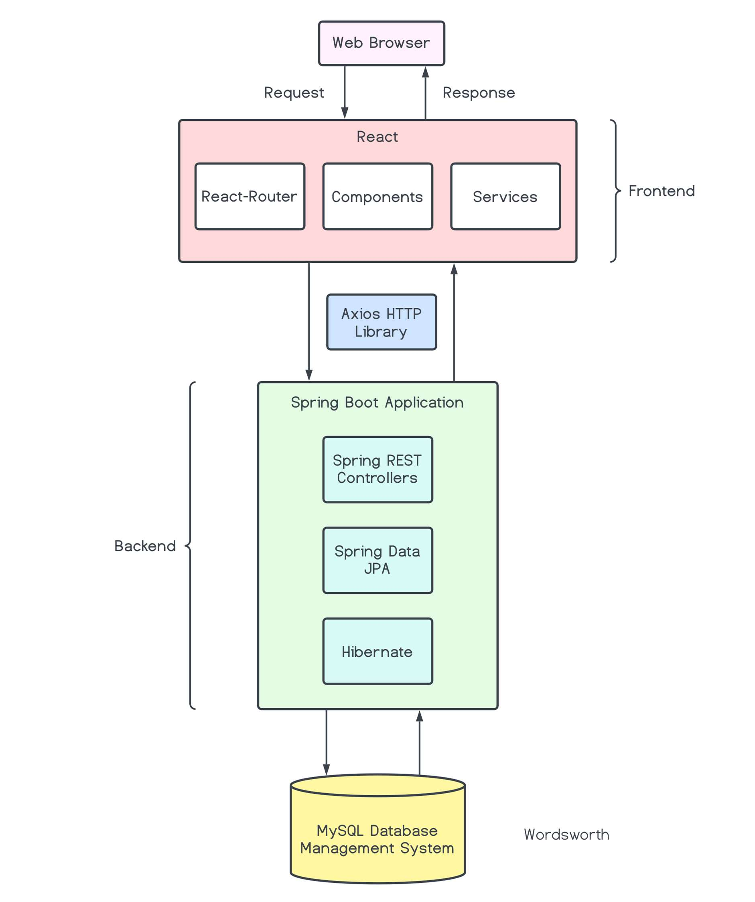

* 1. ER DIAGRAM

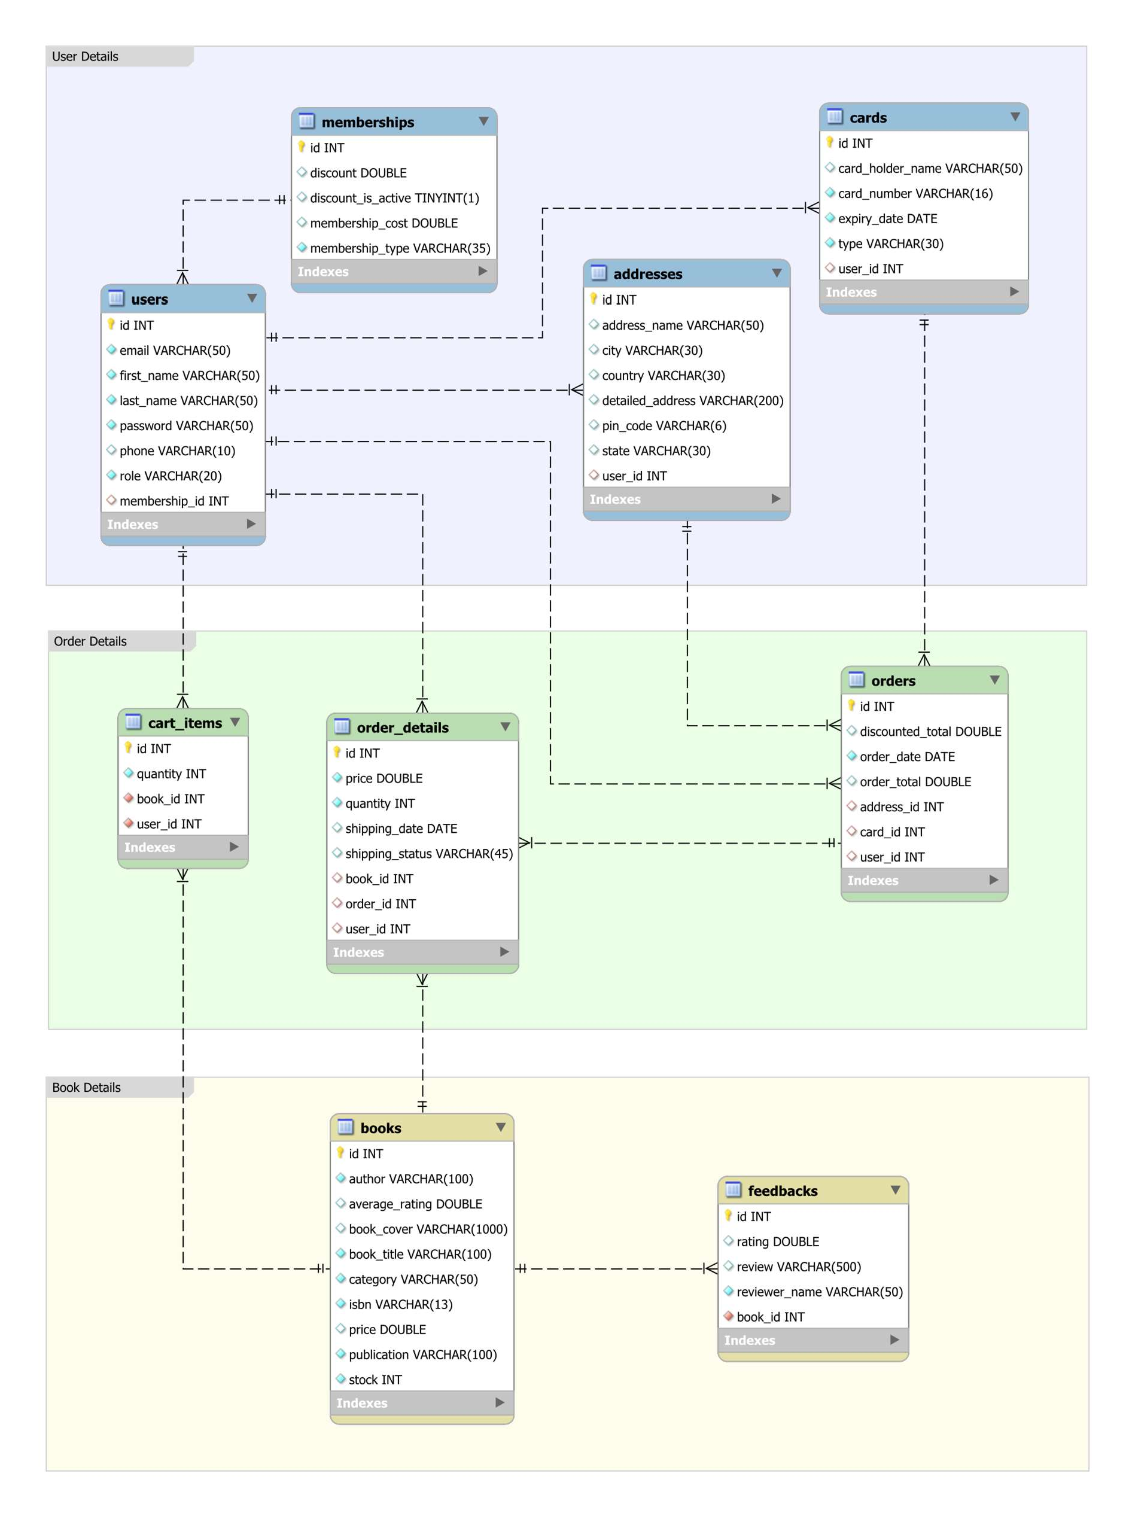

# 5. PROJECT SCREENSHOTS

## 5.1. STUDENT

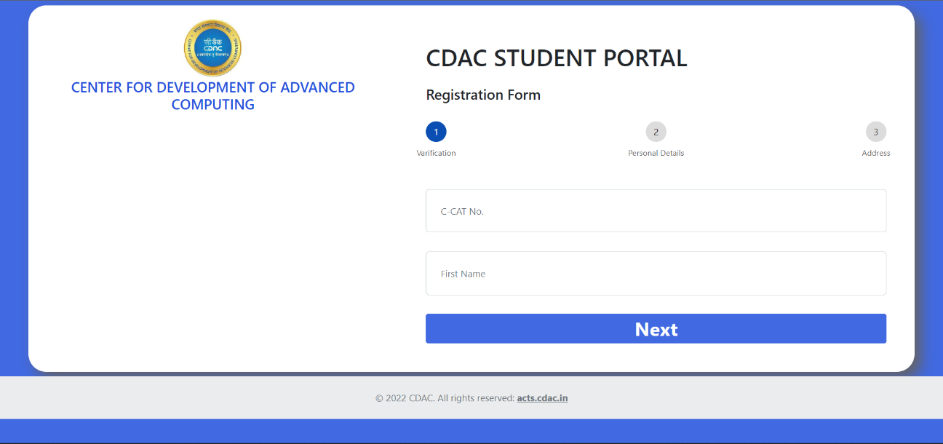

Register

* Only those users are allowed to register who have valid CCAT No and First Name

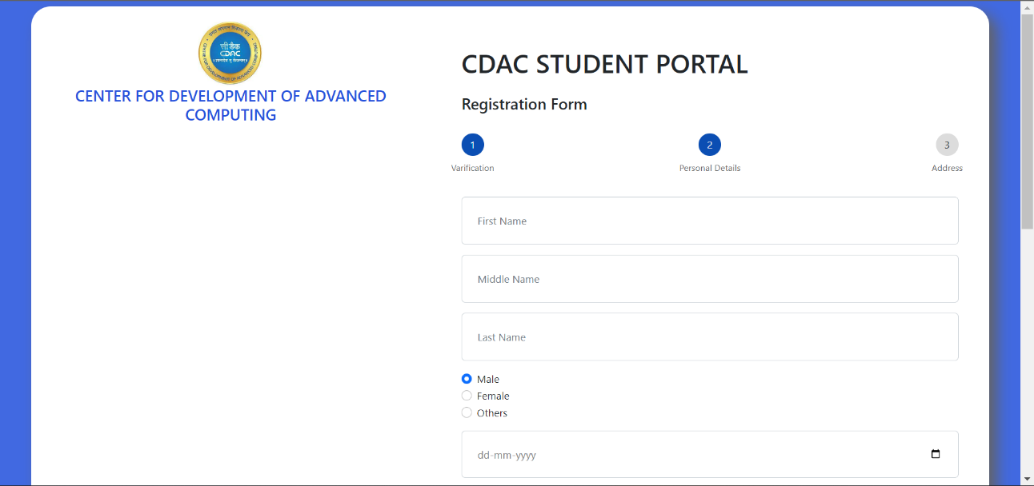

Register

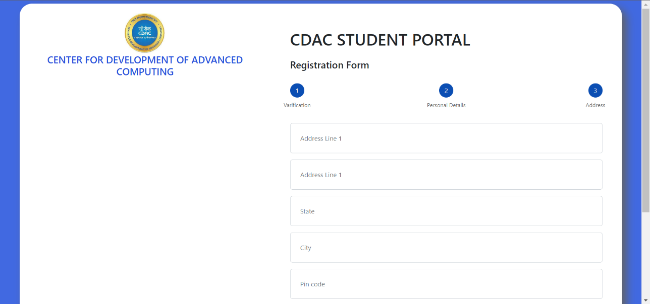

* Once all users are registered successfully, their PRNs are auto-generated.
* Now, users can Login into their portal using PRN as the username and default password.

Login

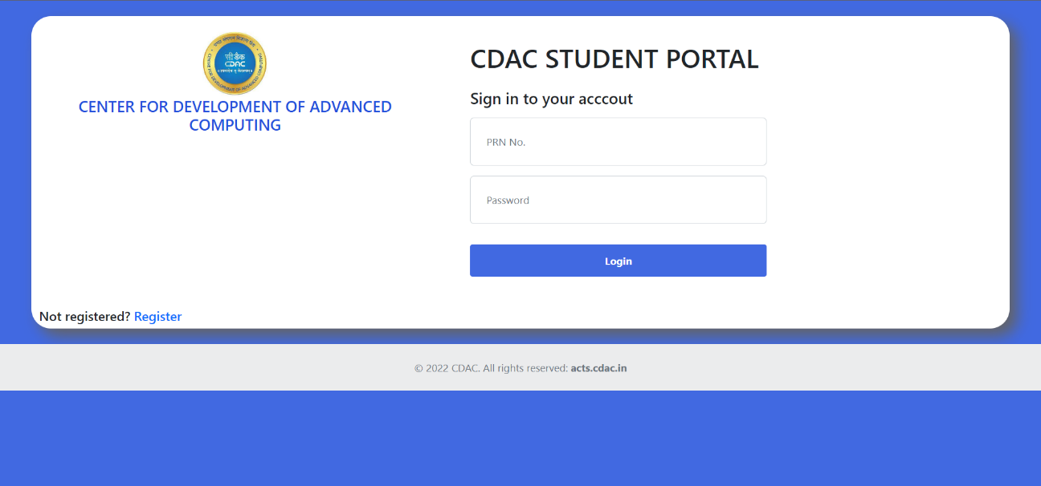

* On successful login, user enters into Dashboard
* There are separate home screens after login for Student and Admin
* Let us first see how Student Portal looks like

Student Dashboard

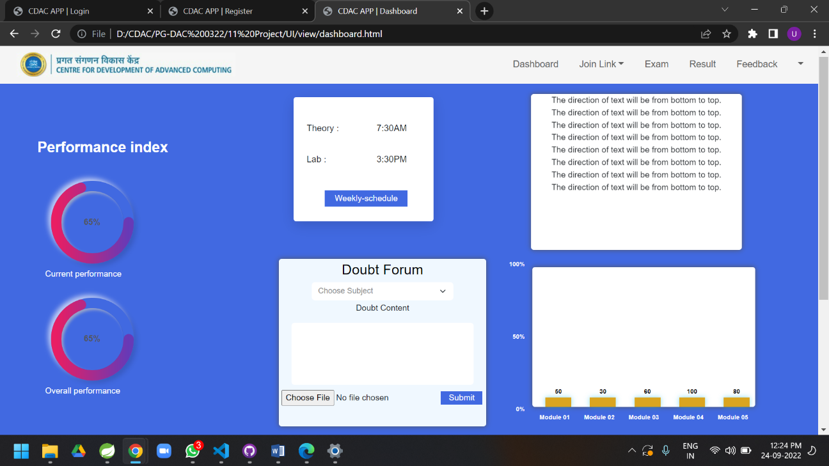

Empty Cart

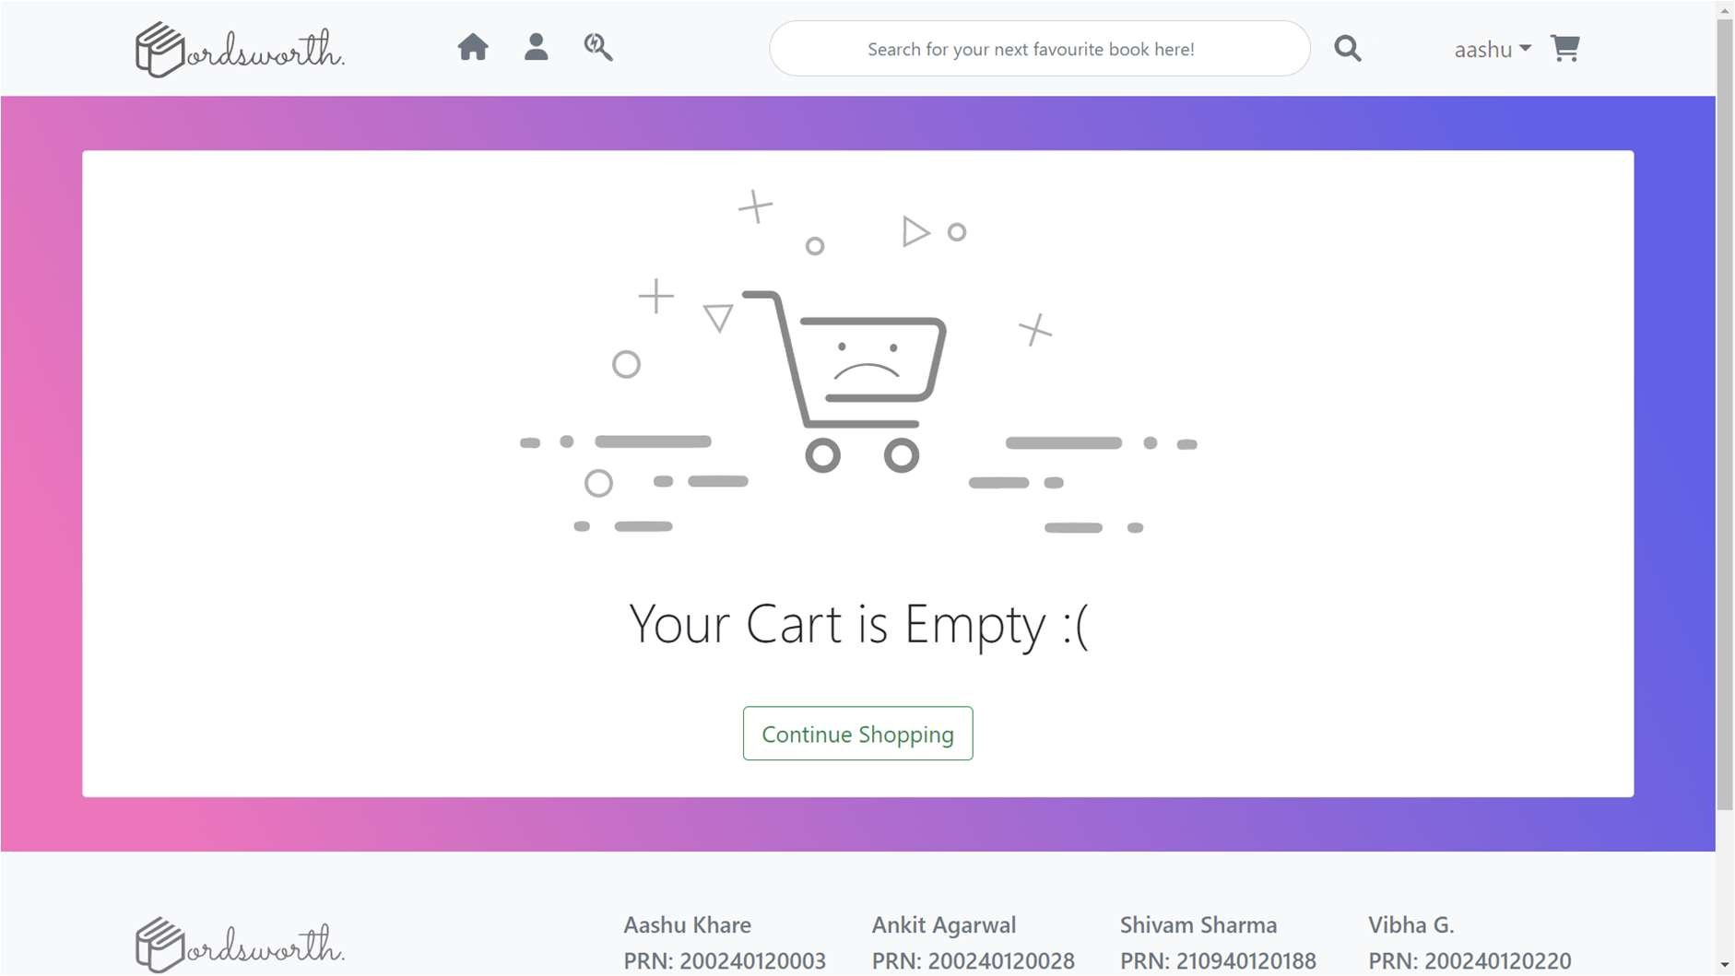

Error when cards and addresses are not added for placing order

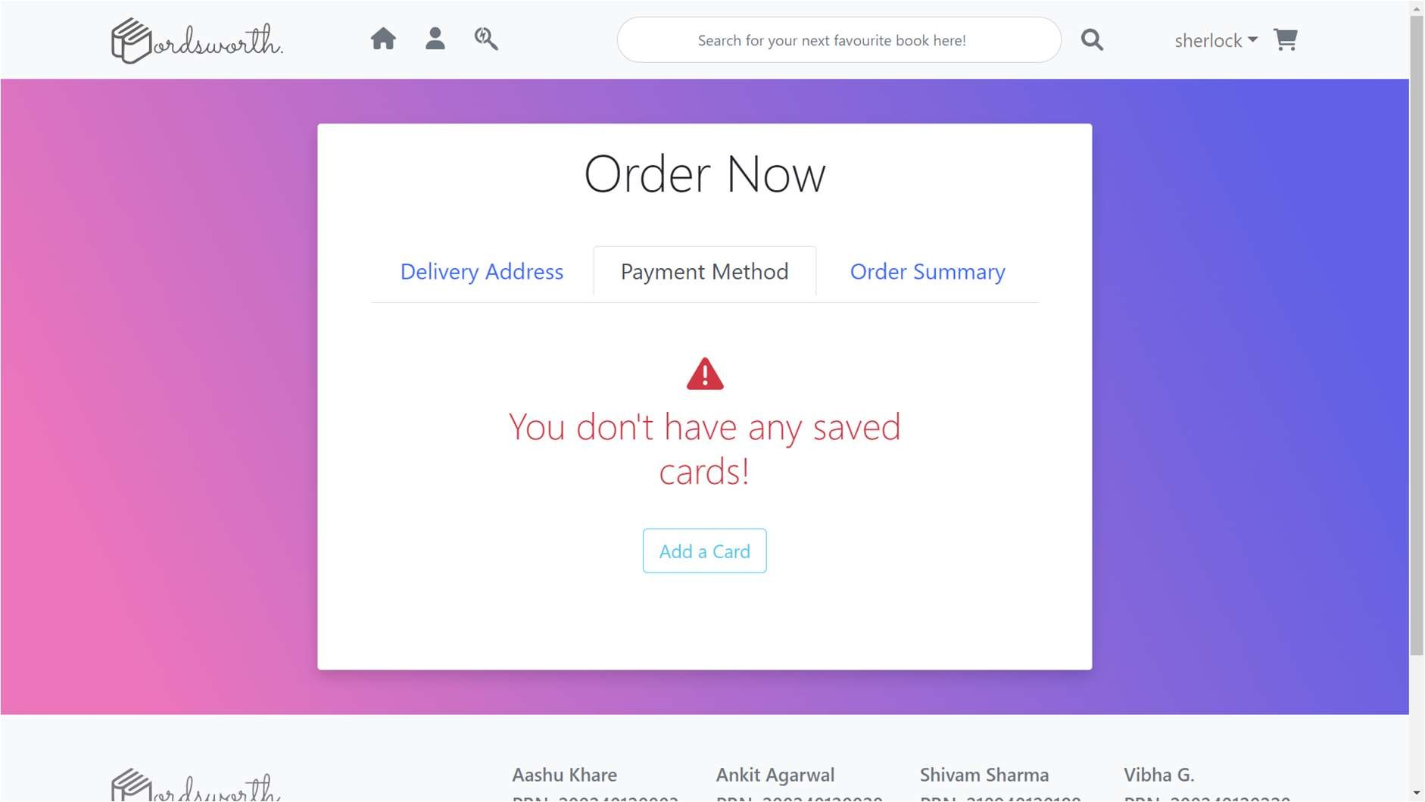

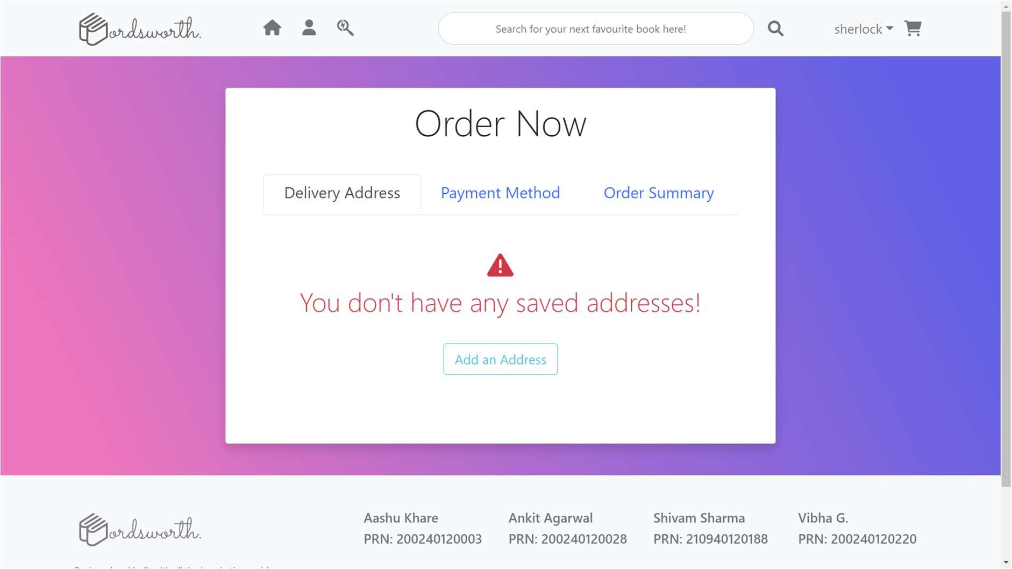

Add an Address for Delivery

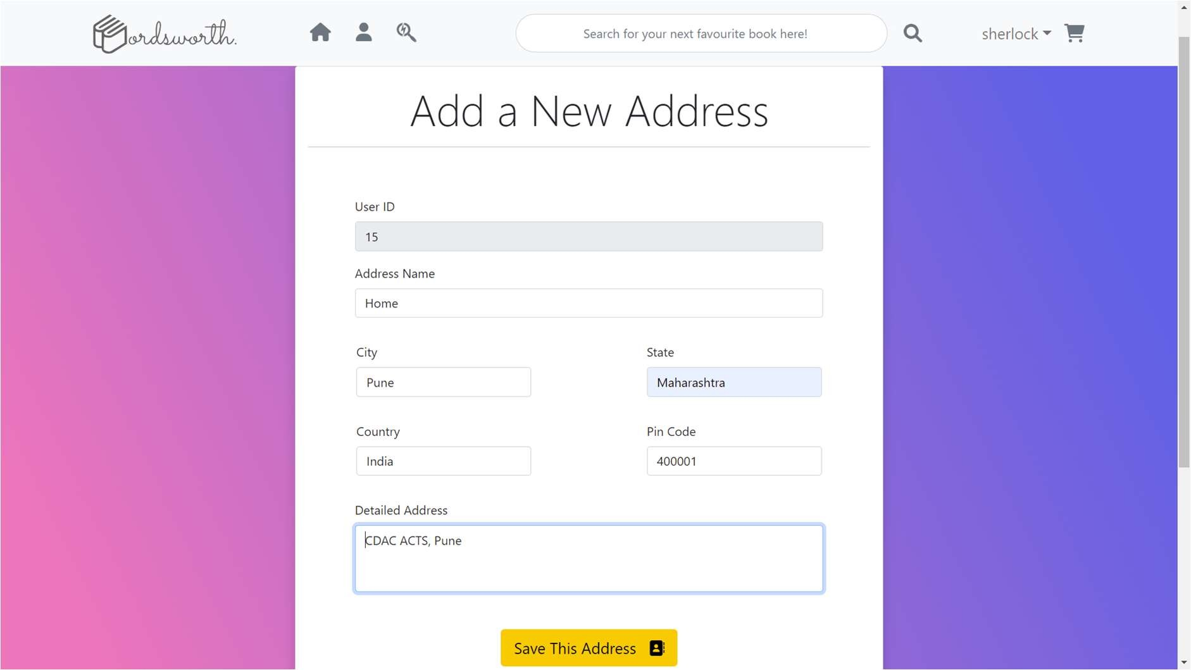

Add a Payment Card

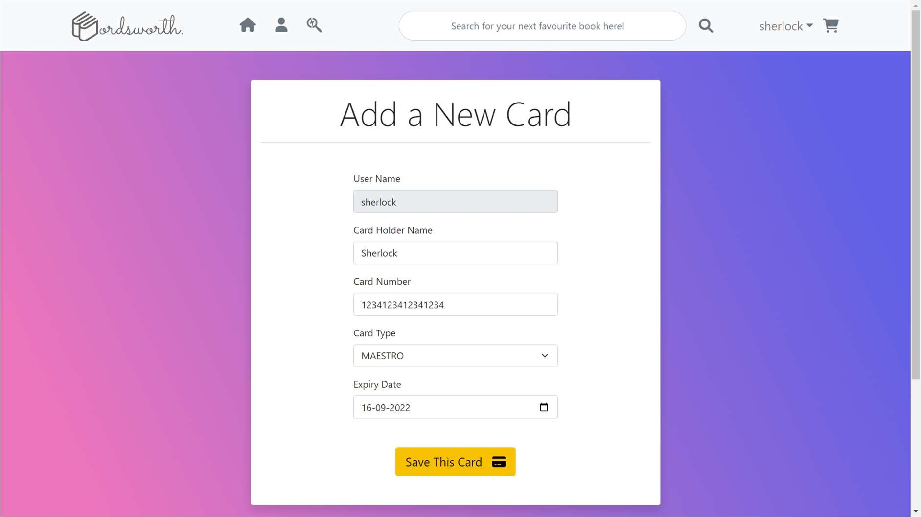

Choosing an Address for placing order

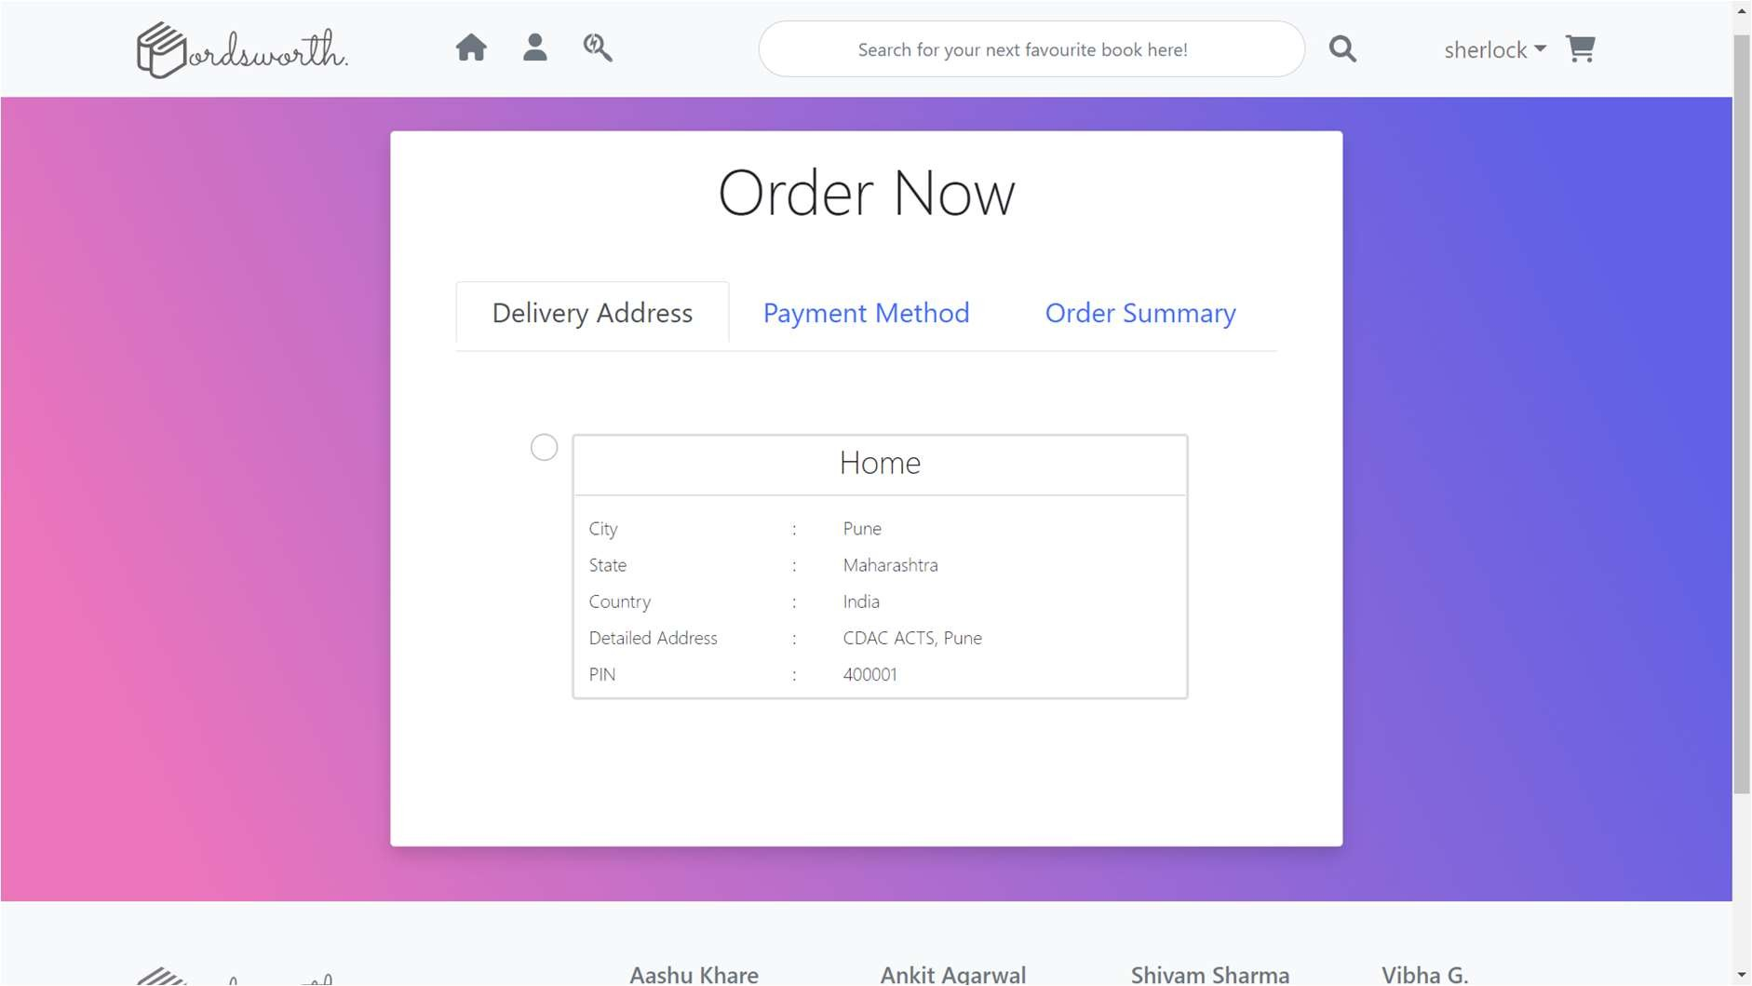

Choosing a Card for placing order

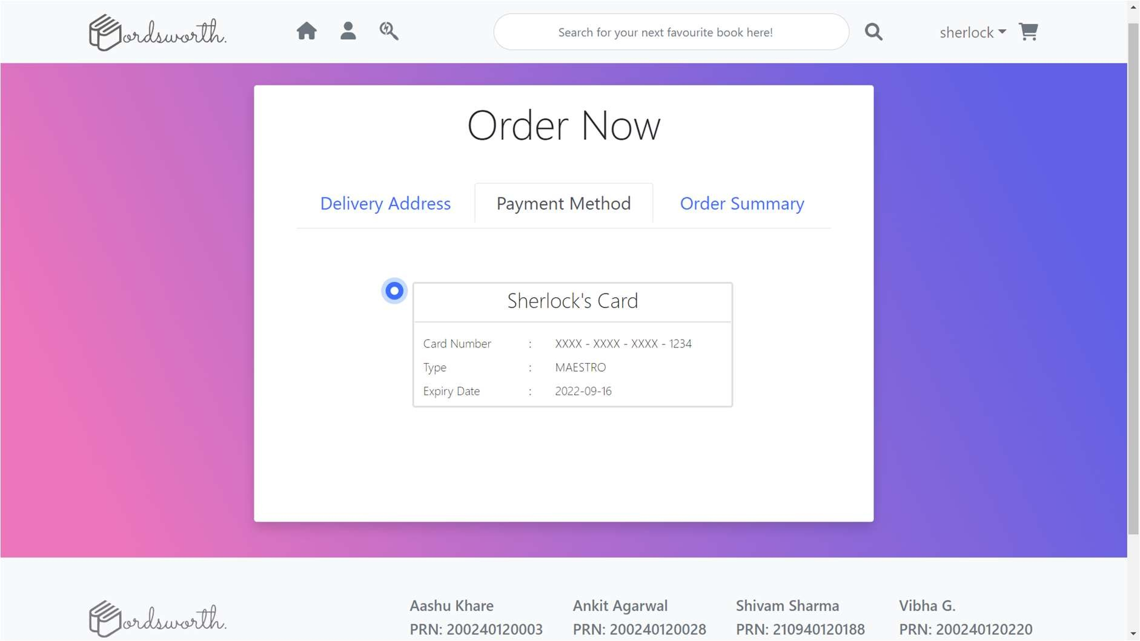

Order Summary

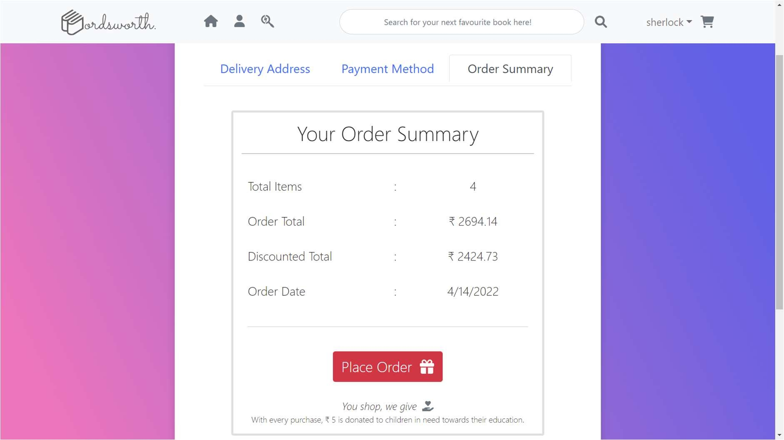

No Past Orders

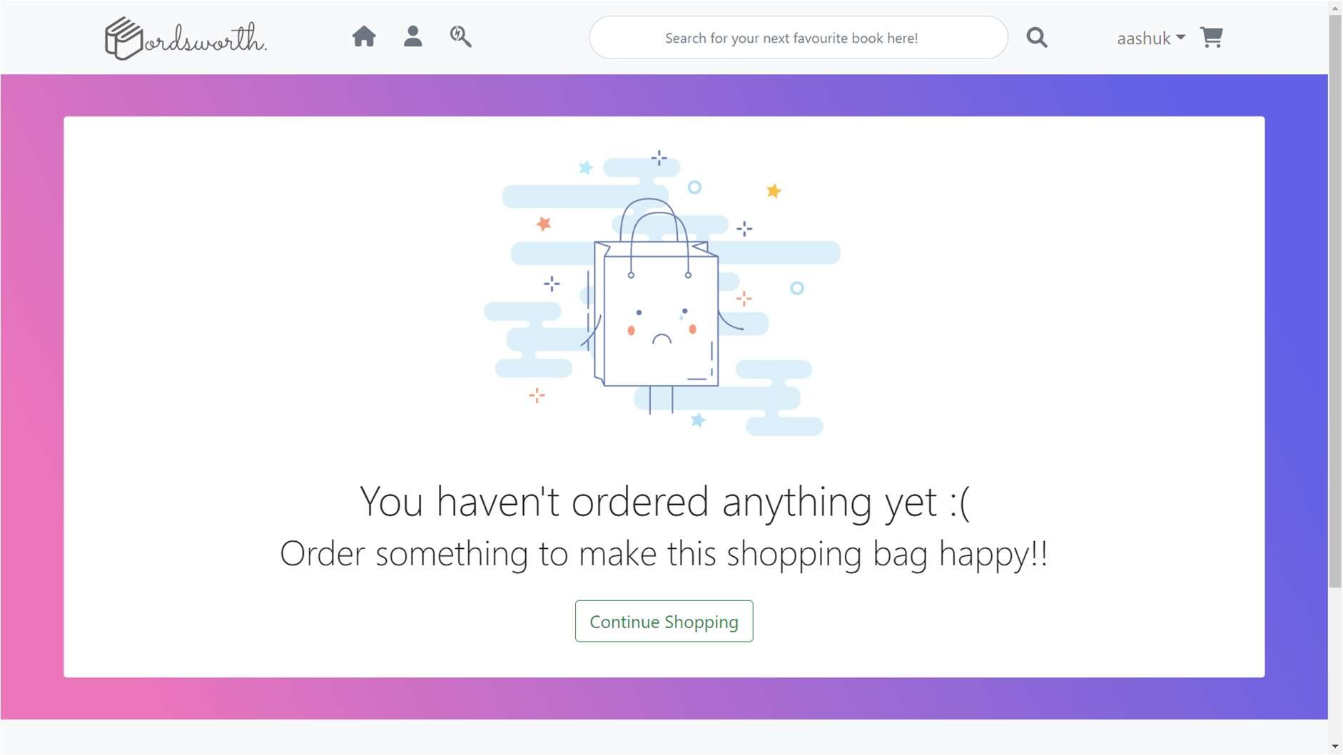

View Order History if there are some orders

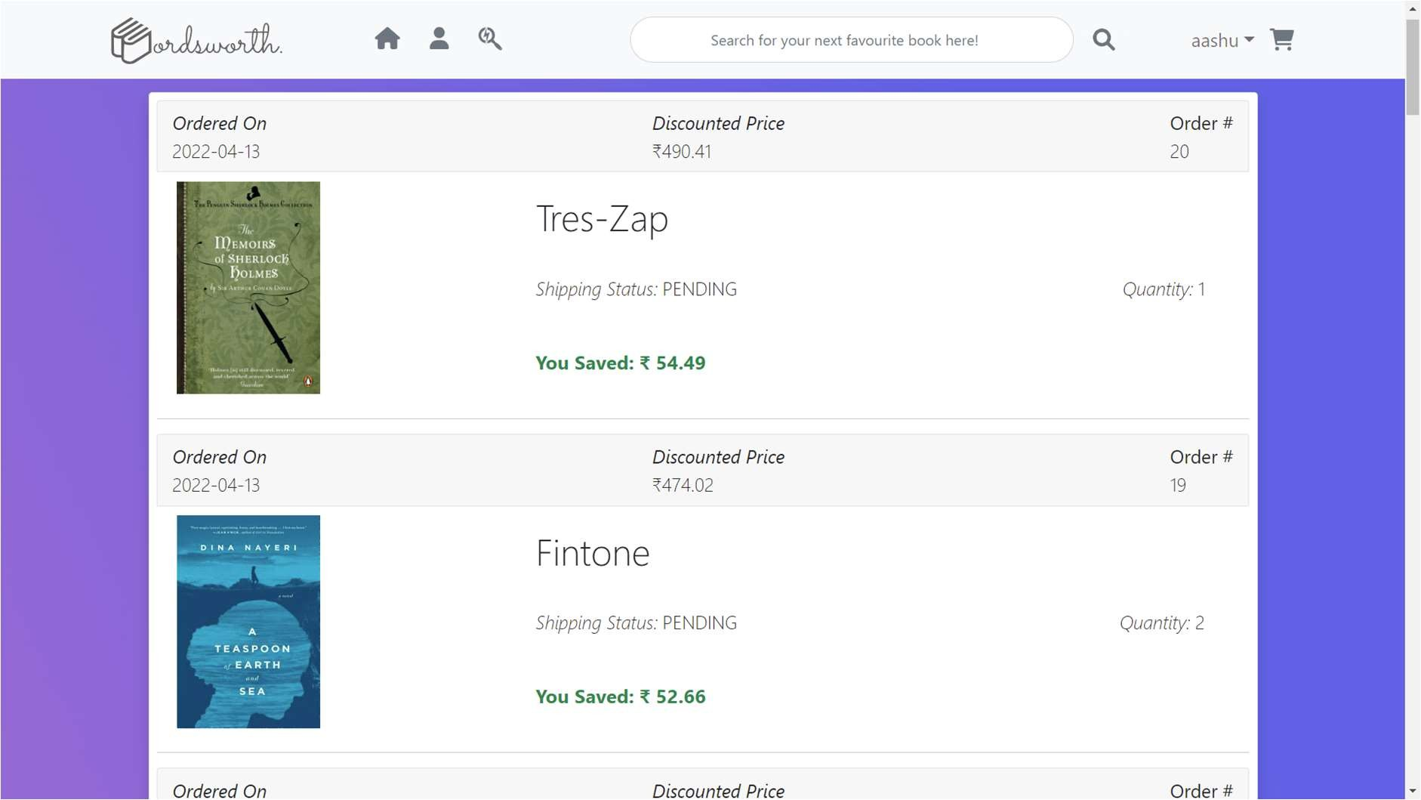

User Dashboard

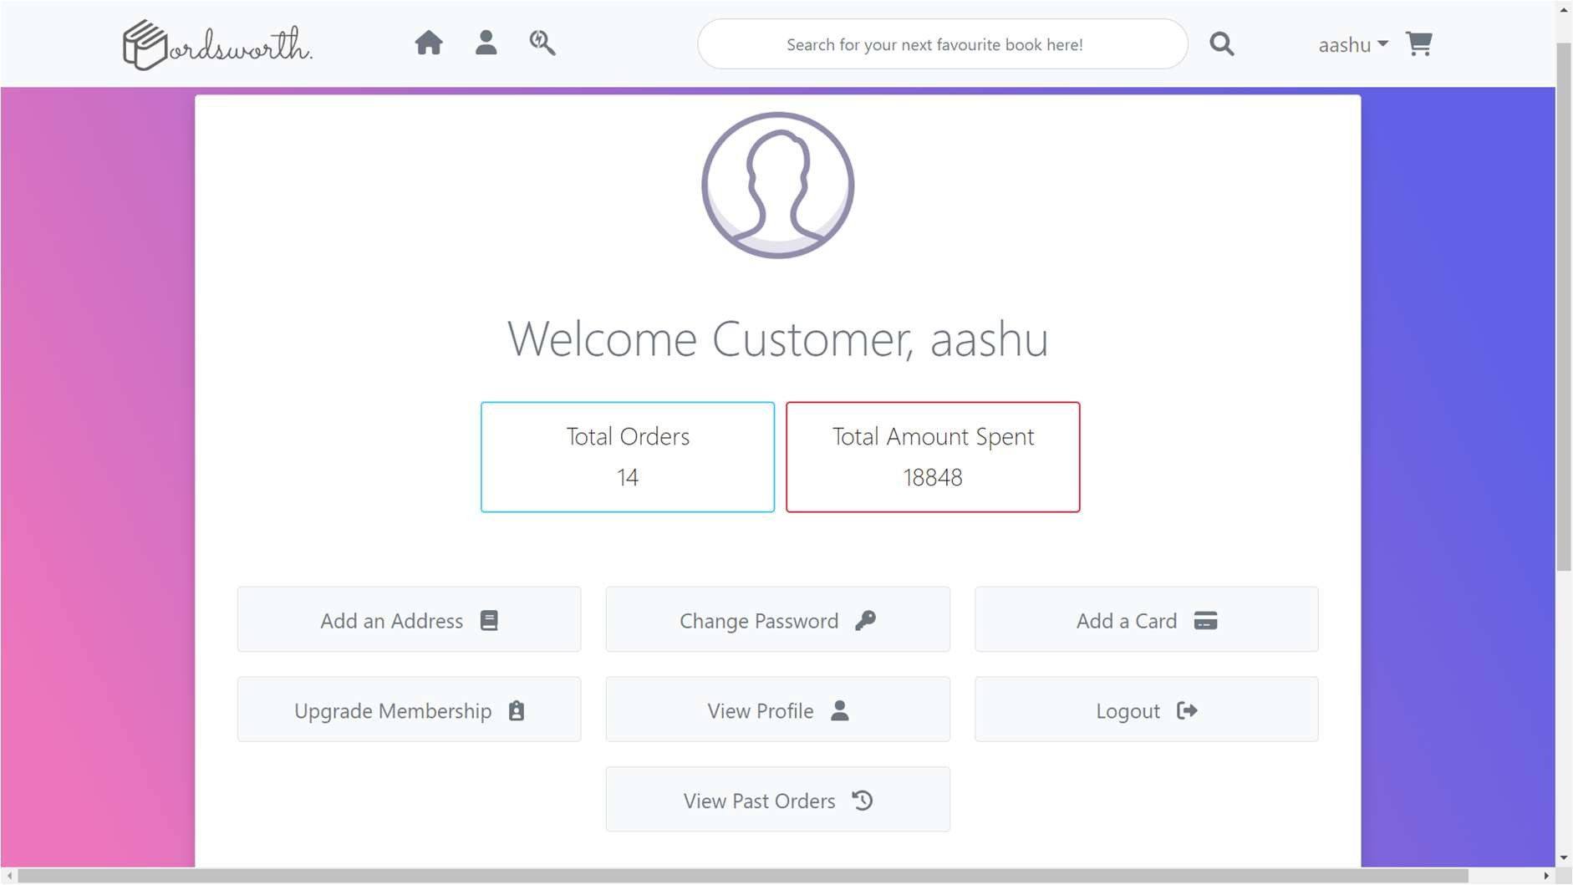

User Profile

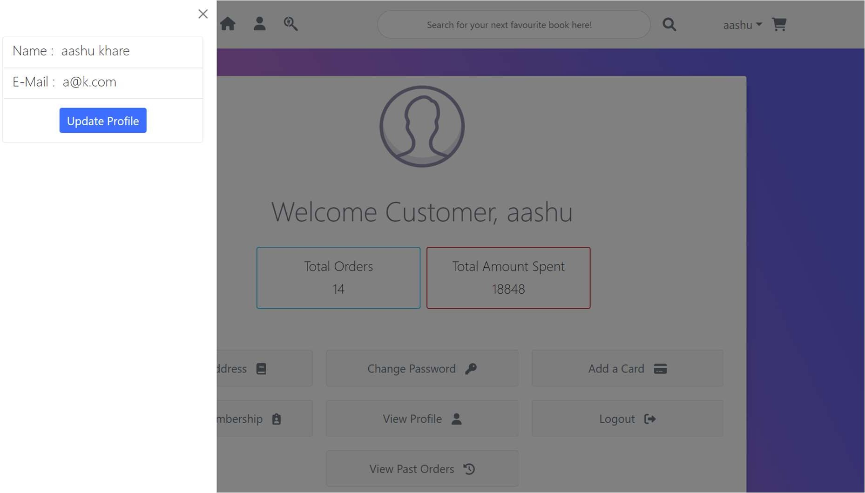

Update Profile

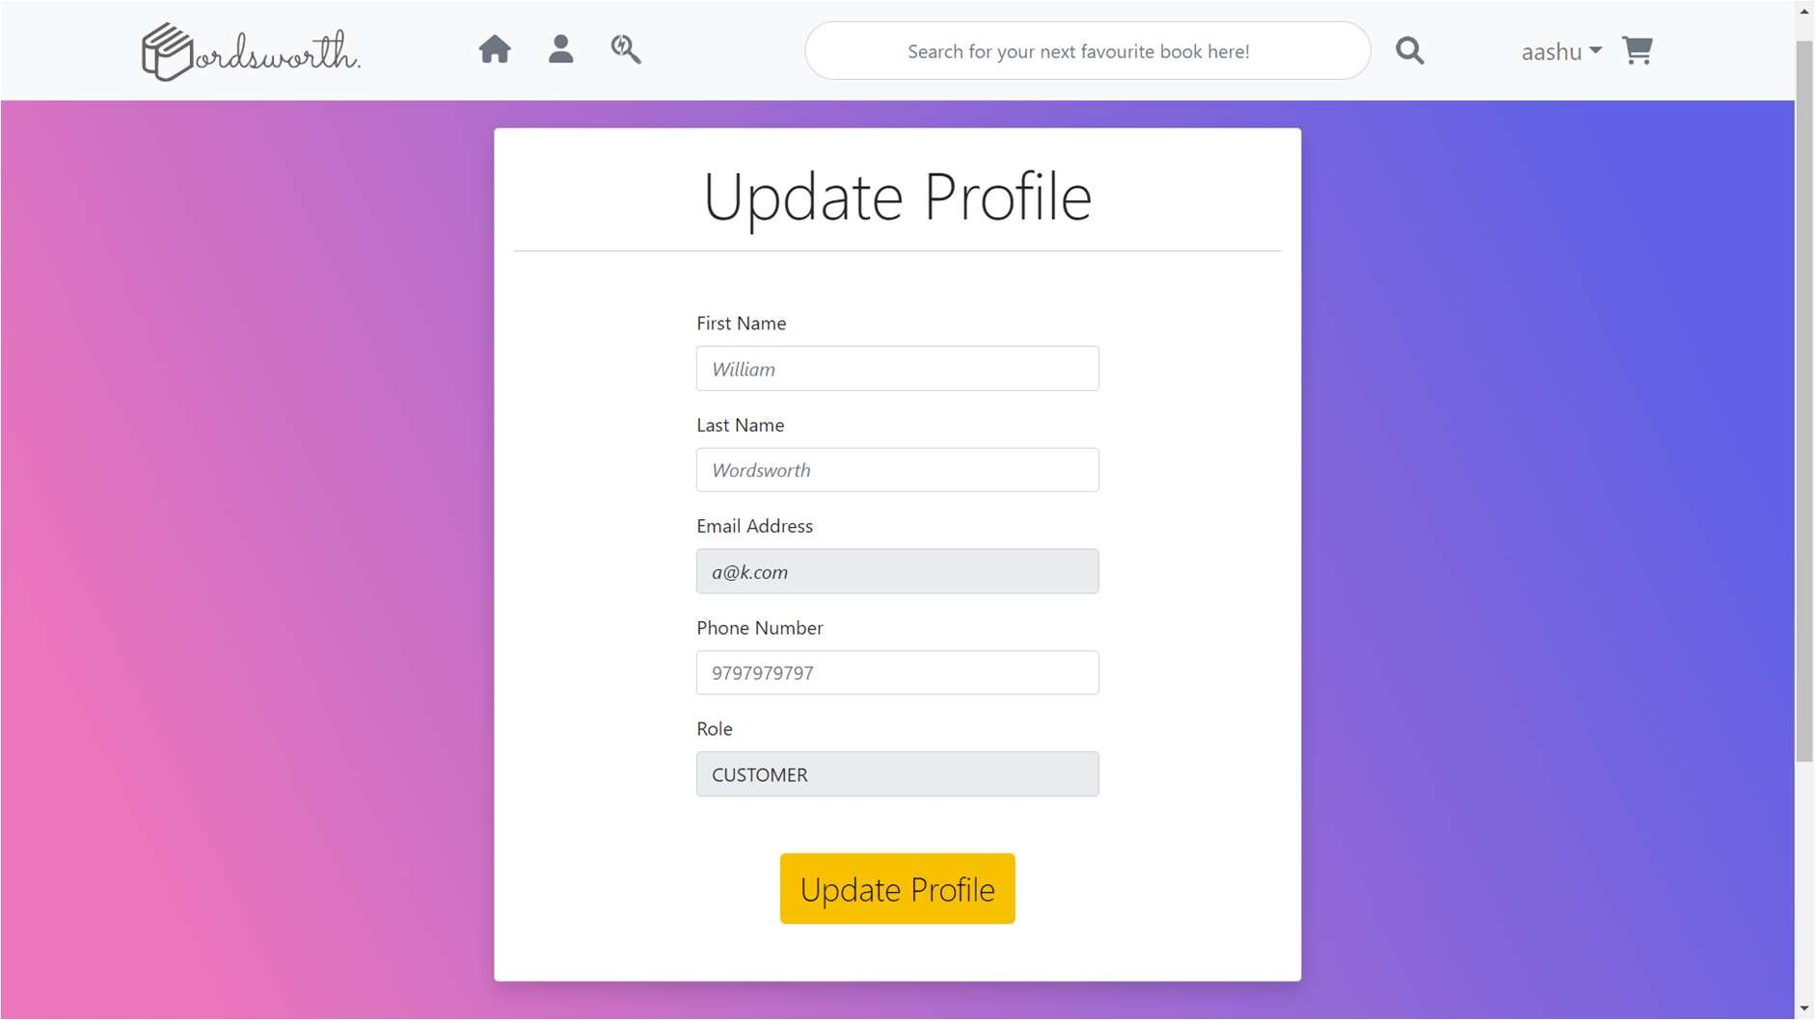

Change Password

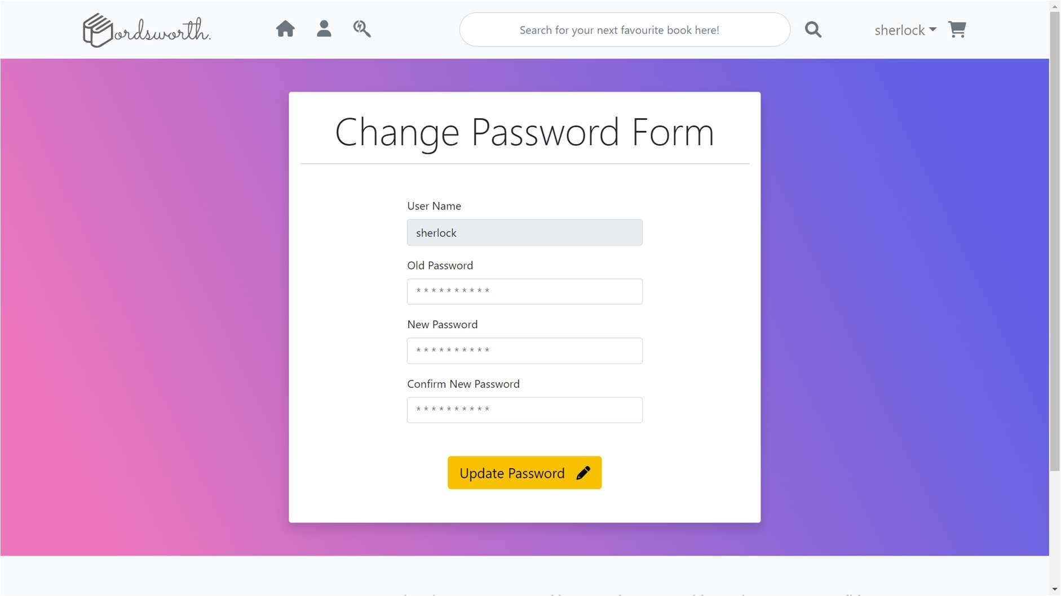

Search by Book Title

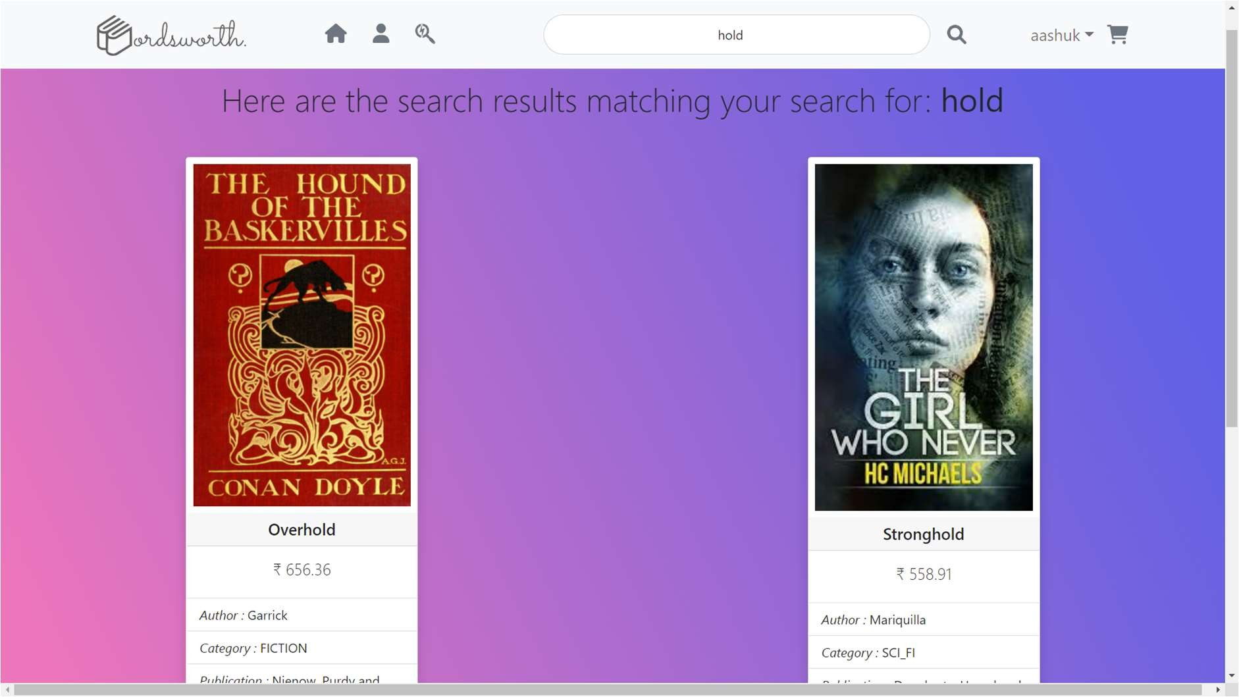

Search by Title if there are no matches

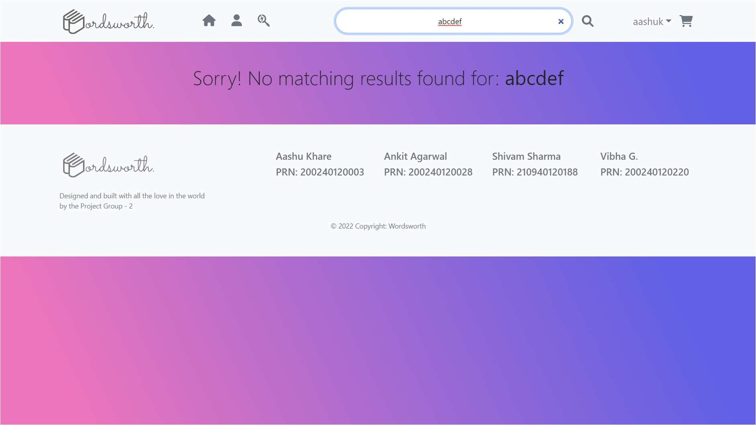

Advanced Search by Criteria

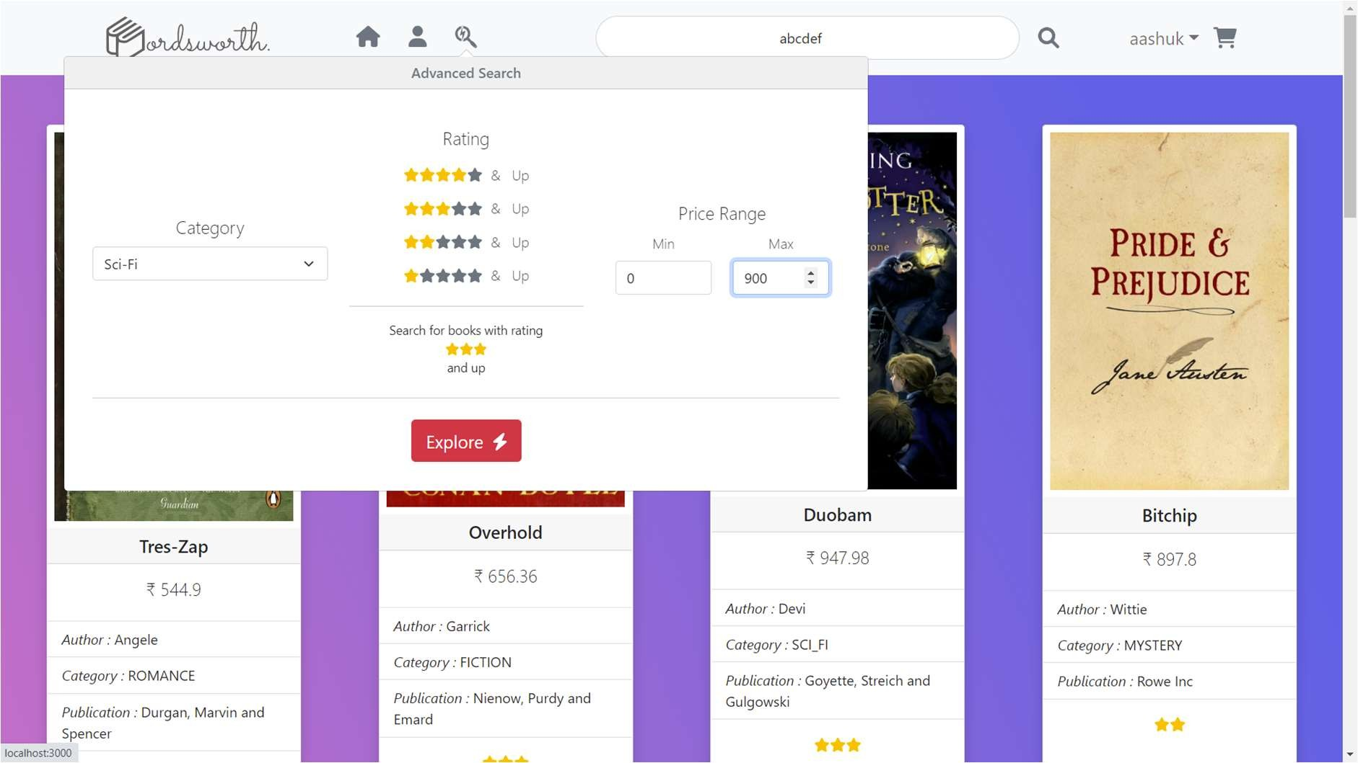

Advanced Search Results

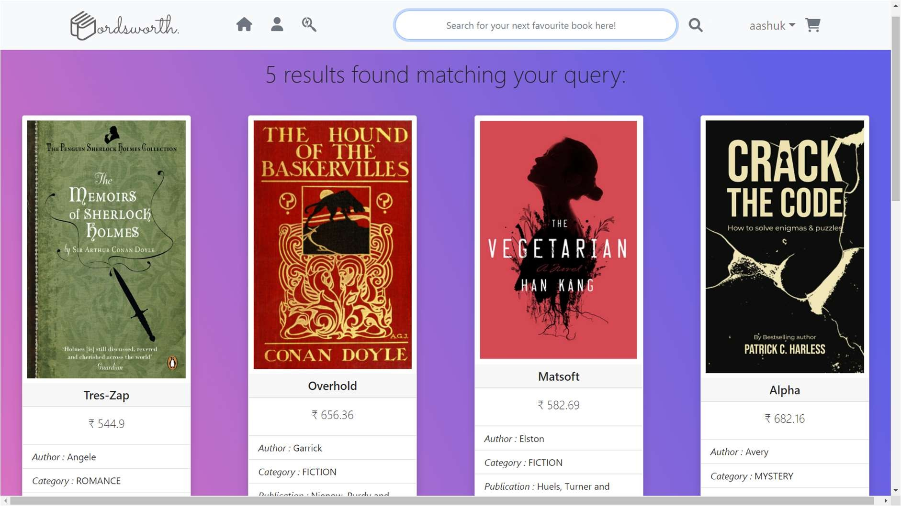

Upgrade Membership Plan

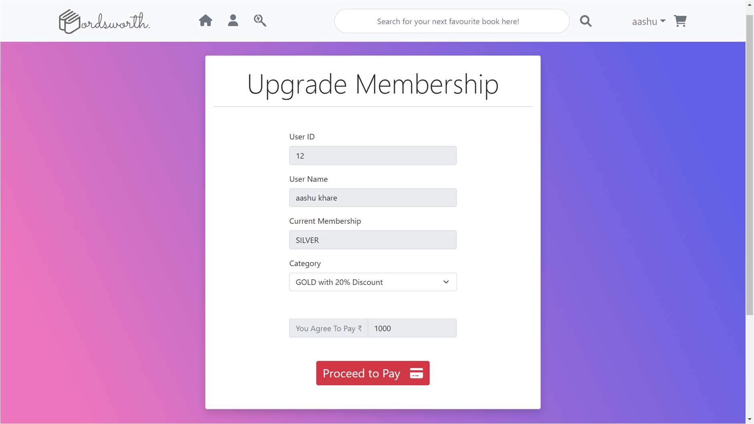

Deregister from website

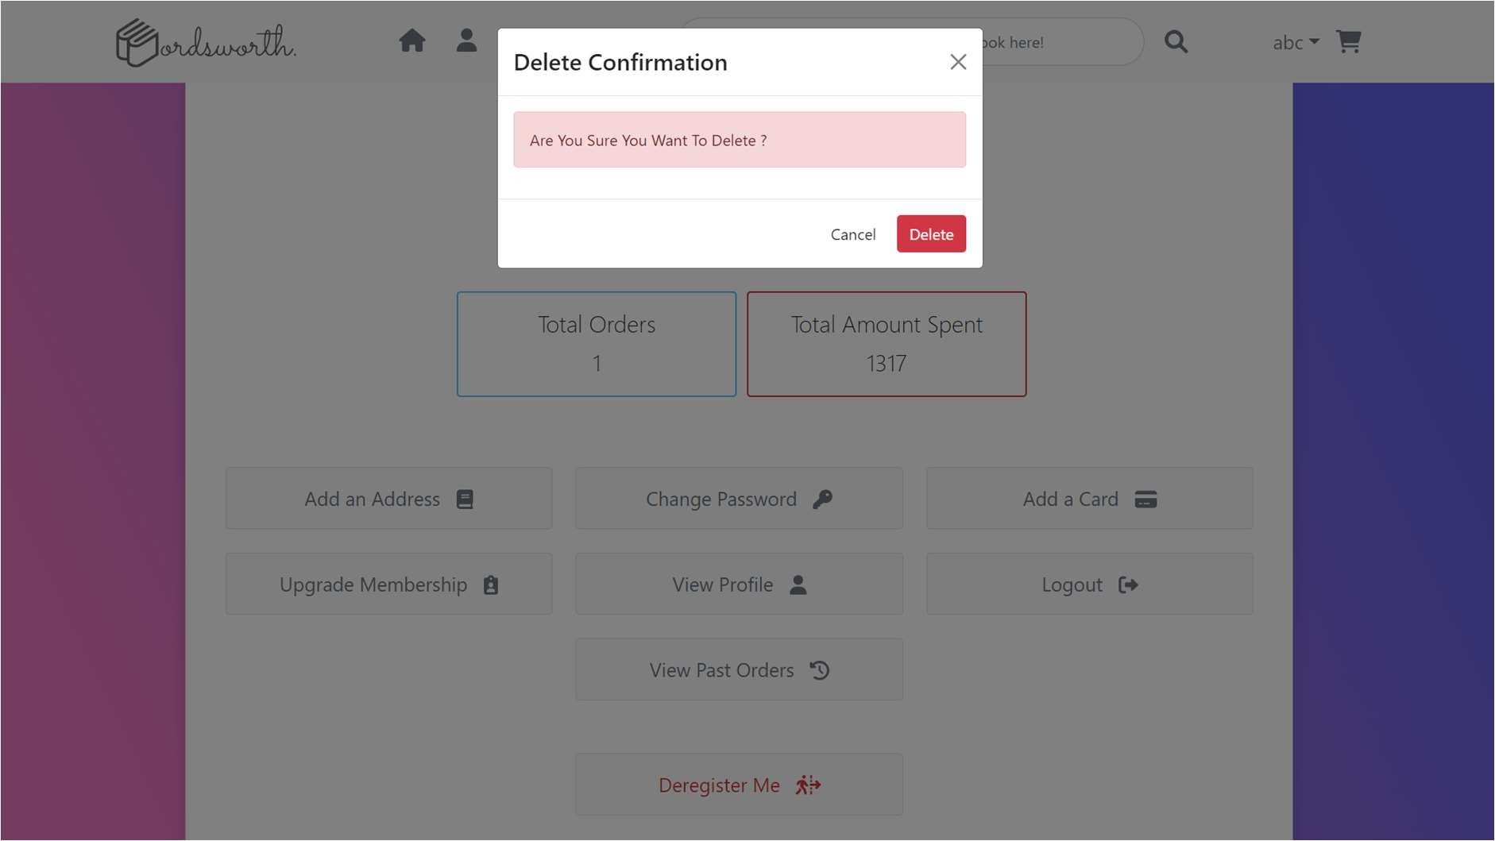

## 5.2. ADMIN

Admin Dashboard

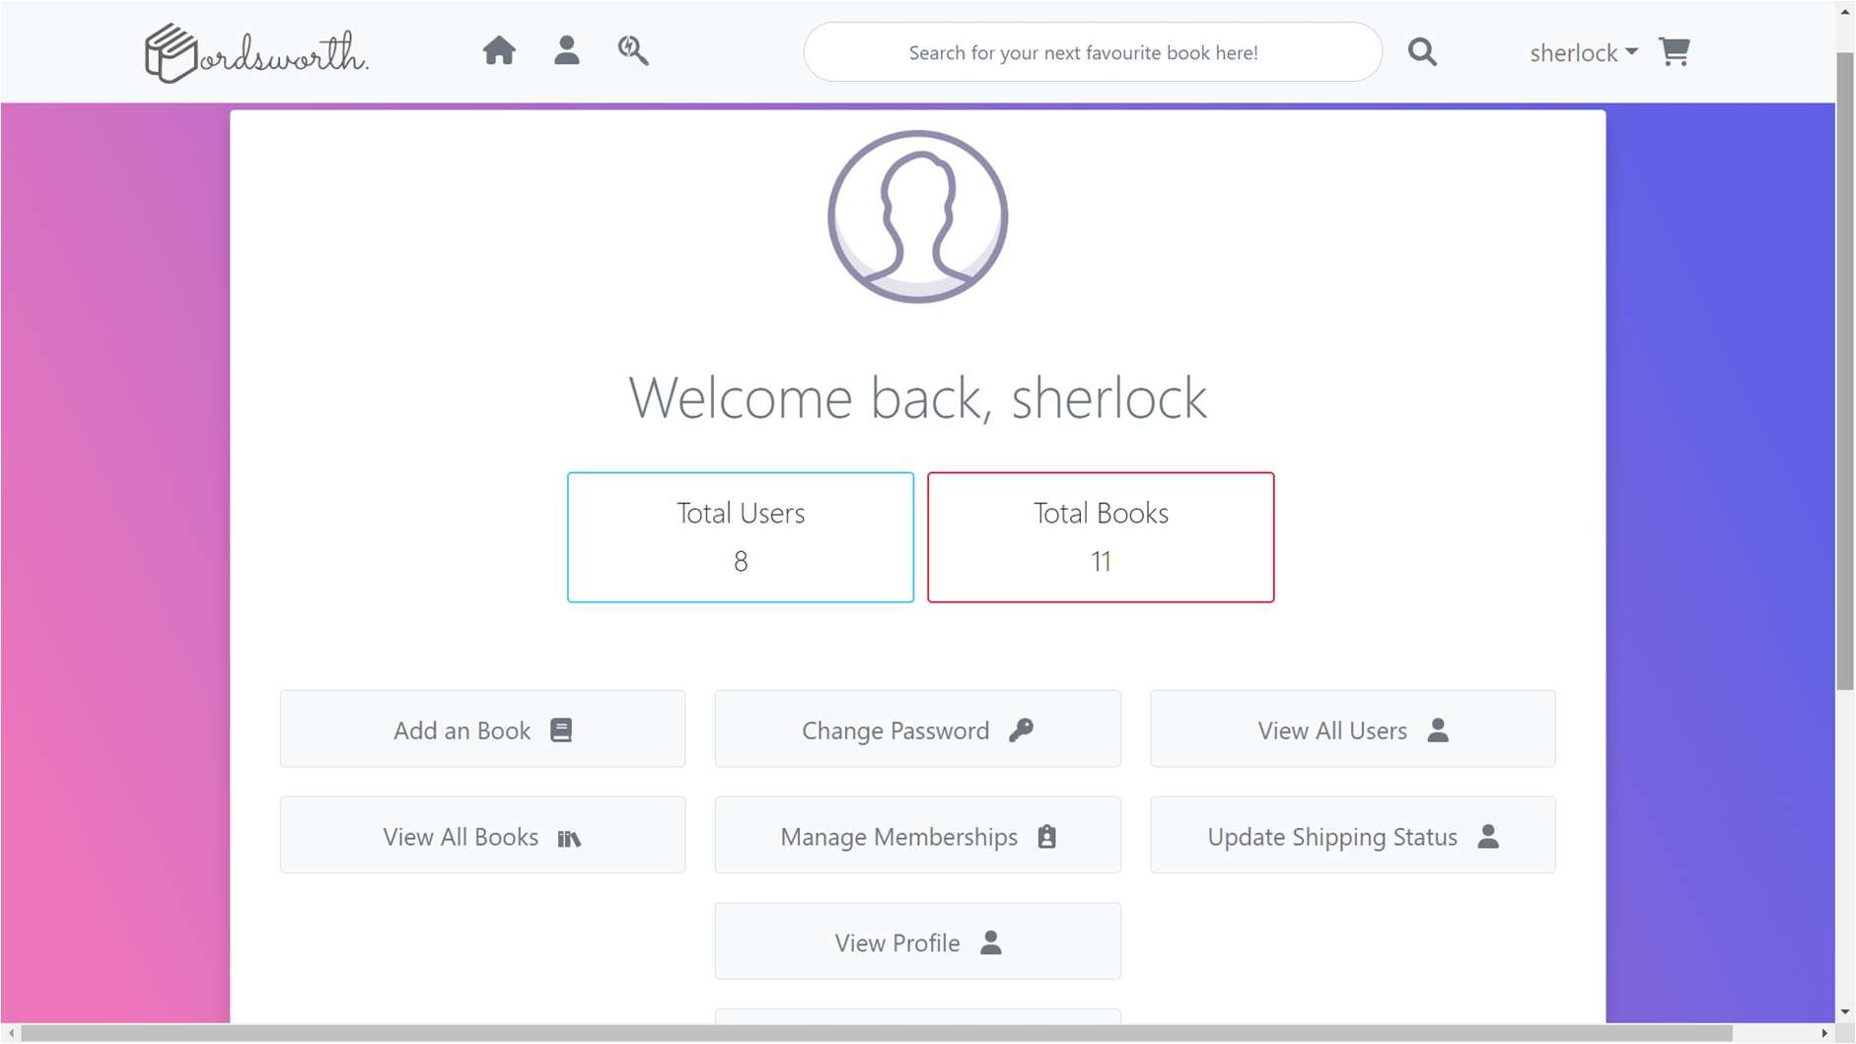

View All Users

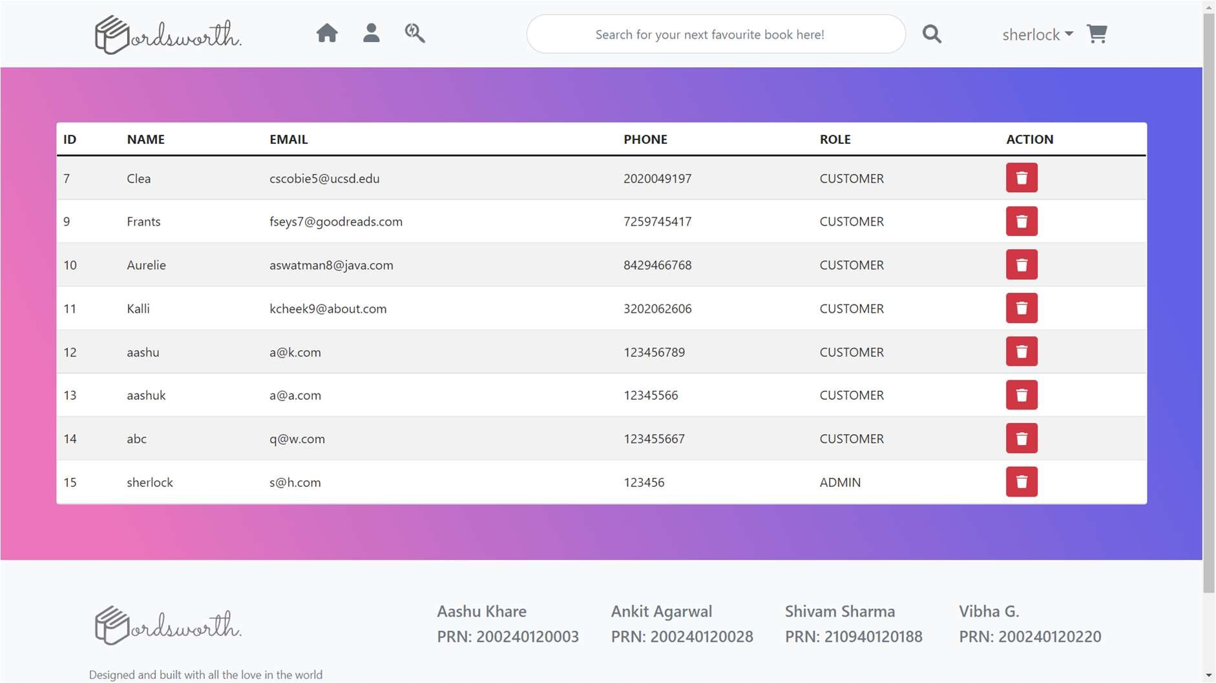

View All Books

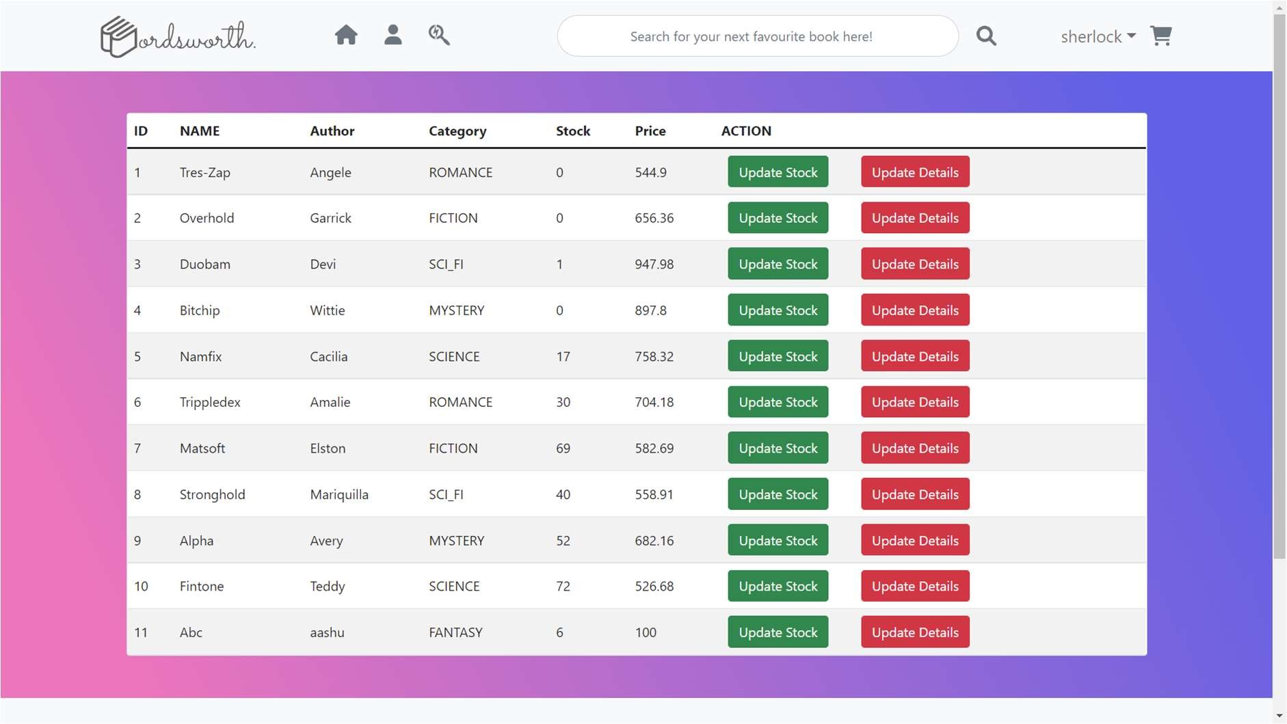

Update Book Stock

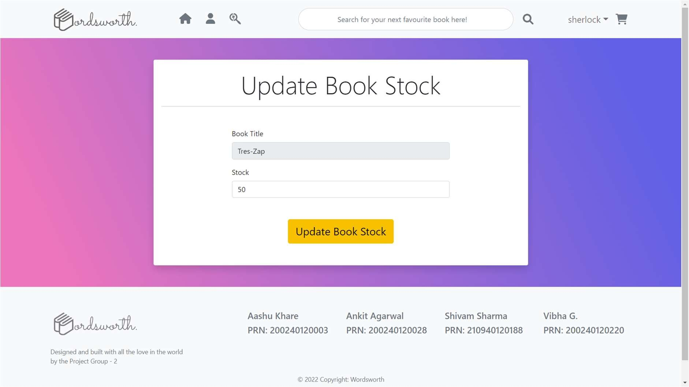

Update Book Details

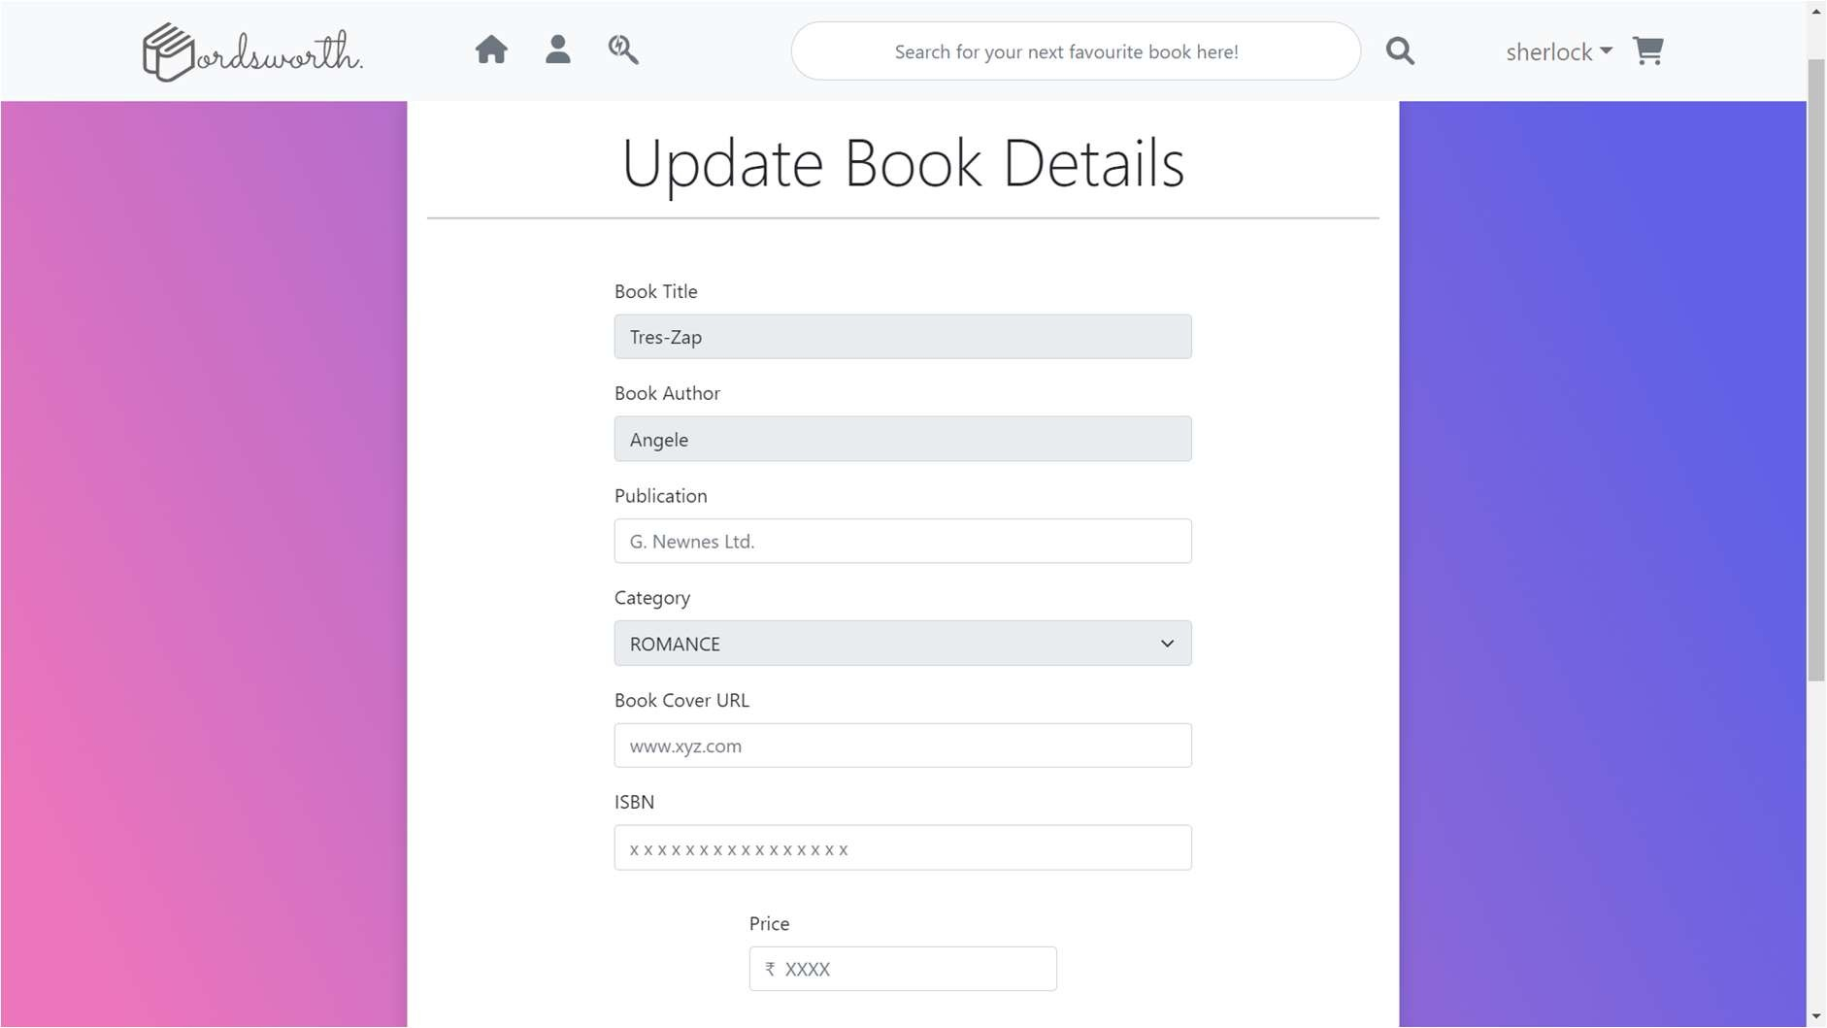

Membership Dashboard

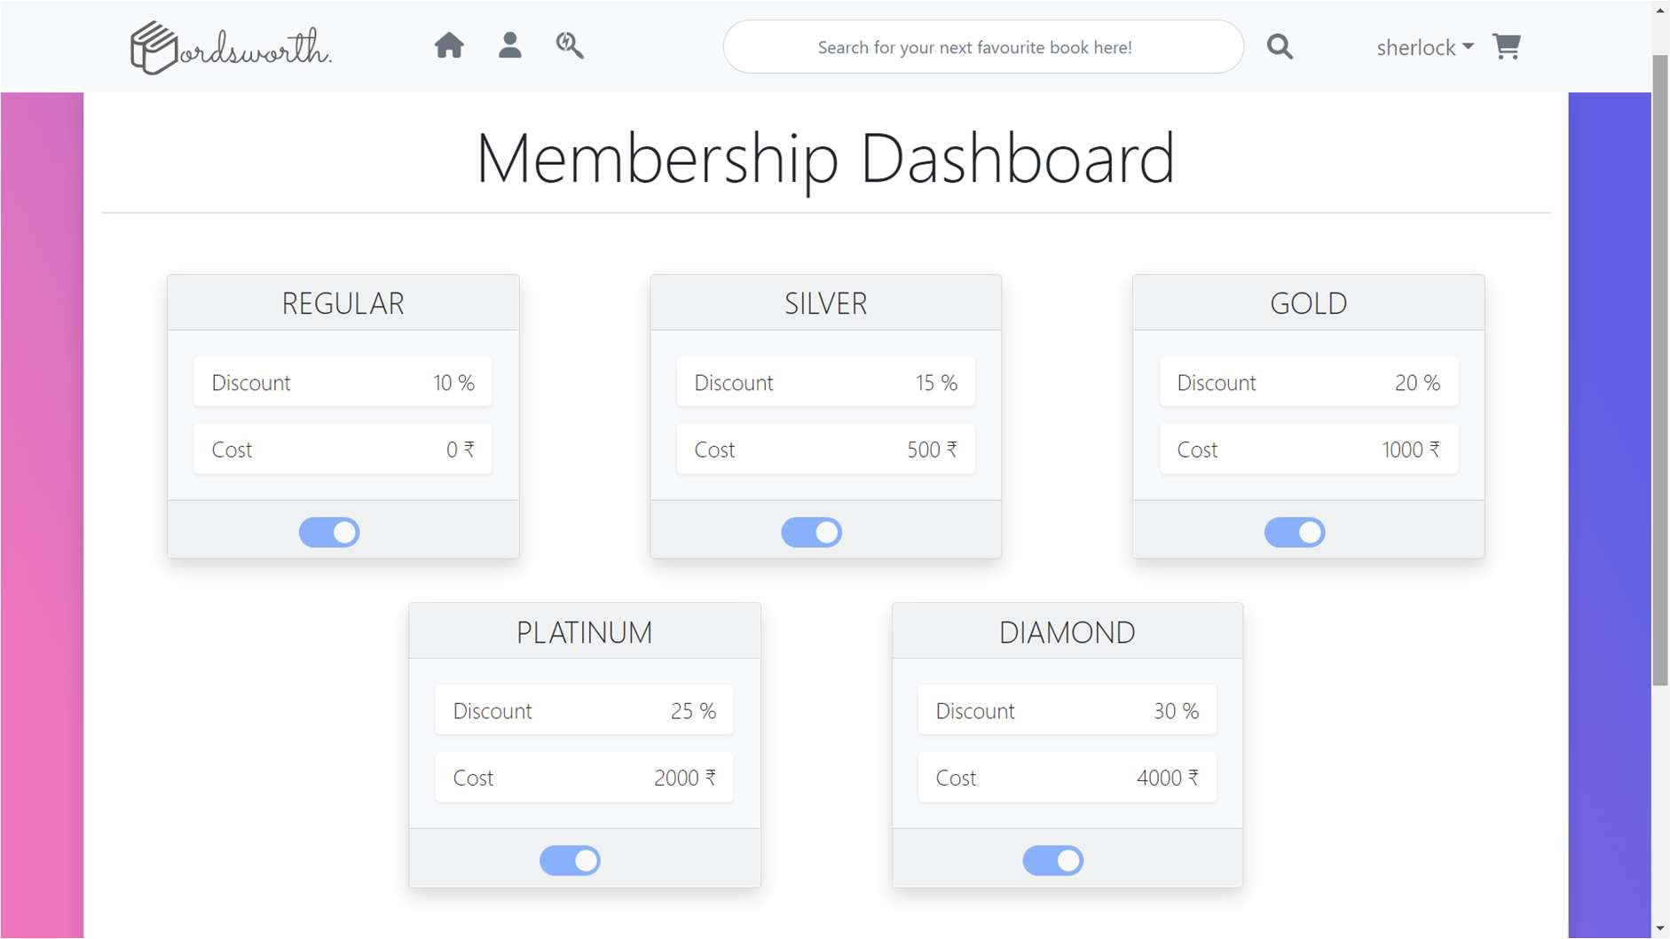

Activate / Inactivate Discounts

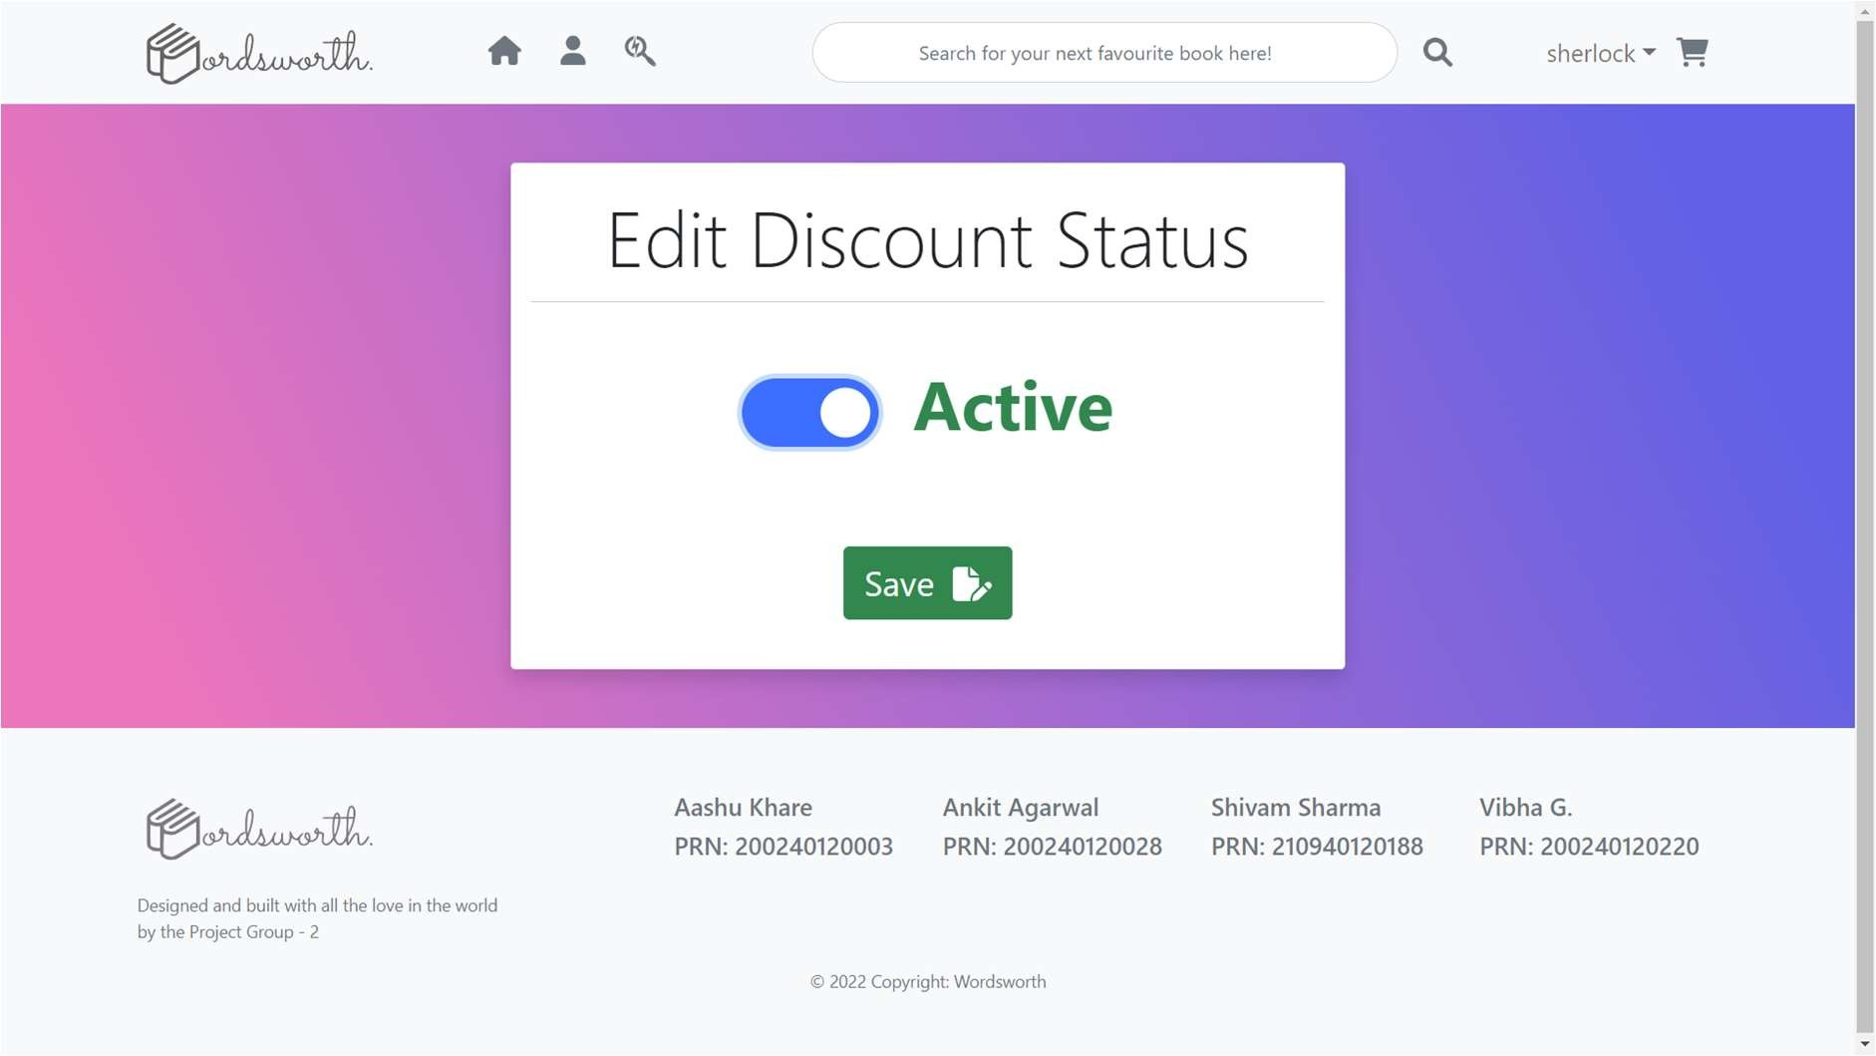

Edit Discount %

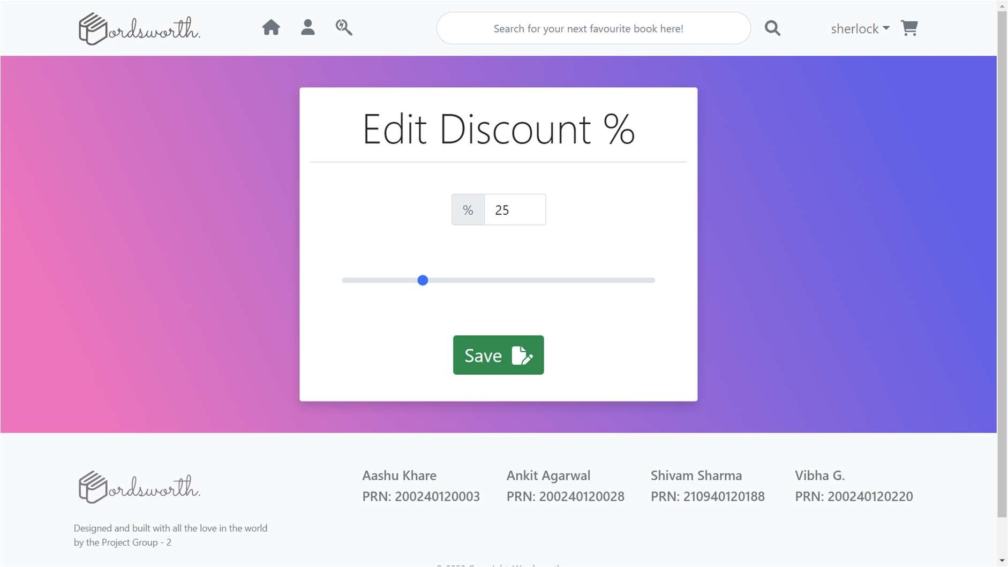

Edit Membership Cost

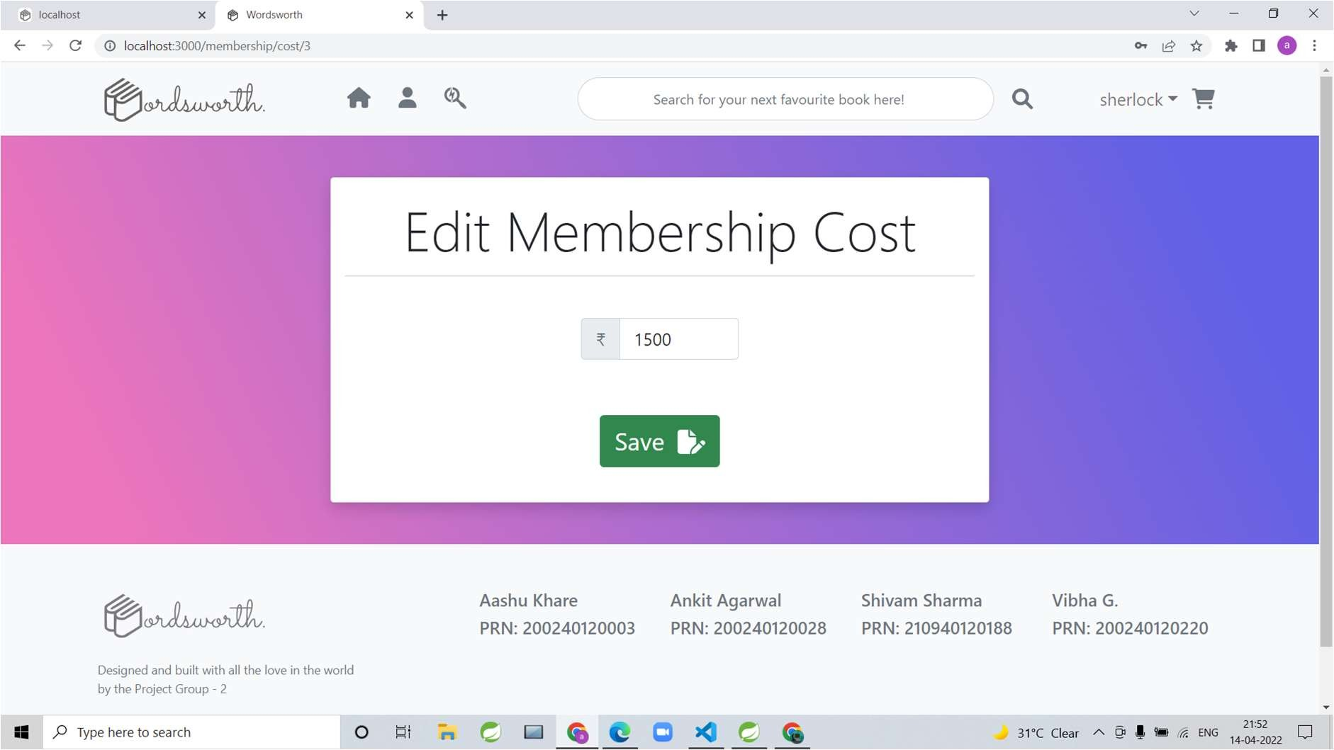

# 6. TESTING

One of the main purposes of testing is to validate and verify that the system works as intended. No program or system design is perfect. However, if we implement the system without proper testing, then it may cause problems and lead to a bad user experience.

Testing and checking outcomes of each test gives us the best chance to detect and correct errors before the system is implemented in a production environment.

In the course of our project, we made an effort to manually test each component. In all cases, we obtained the desired results as demonstrated below.

### A. STUDENT FEATURES TEST

|  |  |  |  |
| --- | --- | --- | --- |
| **#** | **Description** | **Outcome** | **Result** |
| 1. | Register as Student | Students having valid CCAT number only are allowed to register. | Passed |
| 2. | Login as Student | PRNs of students are fetched from database, otherwise login failure message will be printed accordingly. | Passed |
| 3. | Join Link | Lecture and Lab links are fetched from database. | Passed |
| 4. | Attempt Exam | MCQ Exam Papers are fetched after clicking the Start Exam button. | Passed |
| 5. | View Result | MCQ Exam Results are fetched after clicking the View Result button. | Passed |
| 6. | View and Update Profile | Profile can be edited and password can be changed. | Passed |
| 7. | Get Schedule | Current Day Schedule is displayed on the dashboard. | Passed |
| 8. | Ask Doubt on Forum | Doubts asked on Forum are mailed to the respective faculty of the respective module. | Passed |
| 9. | Get Performance Analysis | Current and Overall Performance is calculated and is made accessible to students on their dashboard. | Passed |
| 10. | Get Notice on Noticeboard | Students get notice on notice board which is fetched from admin side. | Passed |
| 11. | Get Attendance Report | Module-wise Attendance of students is fetched from csv uploaded by admin. | Passed |
| 12. | Logout | The session was cleared. | Passed |

B. ADMIN FEATURES TEST

|  |  |  |  |
| --- | --- | --- | --- |
| **#** | **Description** | **Outcome** | **Result** |
| 1. | Login as Admin | Fetched authenticated user details saved in database. | Passed |
| 2. | Generate PRN for students | Registered students’ PRN will be generated in alphabetical orders of their names. | Passed |
| 3. | Upload MCQ Paper | MCQ papers are uploaded as a csv file and can be accessible to students to solve | Passed |
| 4. | Set Result | Result of MCQ test will be calculated and students will be assigned marks. | Passed |
| 5. | Active Doubts | Doubts raised by students are displayed as a list in tabular form. | Passed |
| 6. | Update Active Flag | Doubts that are solved will be removed from the Active Doubts section | Passed |
| 7. | Get Faculty List | List of faculties can be accessed as a file for given course. | Passed |
| 8. | Get Feedback List | Feedbacks given to faculties by students are accessible to admin. | Passed |
| 9. | Upload Attendance | Attendance record is uploaded by the admin using csv file. | Passed |
| 10. | Upload Links | Links for lectures and labs are uploaded to the database. | Passed |
| 11. | Upload Notice | Notice can be uploaded on floating notice board. | Passed |

# 7. CONCLUSION

“CDAC APP”, an online student management portal, was developed by our project team to provide a platform for PG Diploma courses of CDAC ACTS Pune students and to simplify the admin’s work. We tried using the latest technologies that are cross-platform and robust. Each and every software we used was open-source in nature, which keeps the cost of production at a minimum.

We were also meticulous about the user experience aspect of our application so that navigating our website is an easy and seamless experience.

In conclusion, “CDAC APP” as a portal would definitely be beneficial for CDAC ACTS Pune for managing their PG Diploma students in Online Mode efficiently. We are confident that the numerous features and visually appealing look of the portal will definitely make this portal effective for all the students and admins. This portal can be scaled on higher side to add more features to it.

# 8. FUTURE SCOPE

Using whatever we have learnt over the duration of this course, we tried to make our project as user-friendly and gave it as many features as possible in the limited time allotted for the project work. That said, there are certainly more features that can be added to our application. Some of those are mentioned below:

* 1. Admin functionalities can be improved for larger scale.
  2. More number of courses can be added in the app.
  3. If a user forgets password, OTP can be sent to his/her registered mobile

number and registered Email Id to reset password.

* 1. Students can have Doubt Sessions with faculties.
  2. To improve the app on very large scale, lectures and labs can be conducted in the portal only.
  3. CAPTCHA can be added to login page.
  4. Overall portal can be built on a higher scale so that all functionalities of student management for all courses offered in CDAC ACTS work inside this one portal only.

# 9. REFERENCES

Following is the list of websites we referred during the course of our project:

* + 1. https://getbootstrap.com/docs/5.1/getting-started/introduction/
    2. https://reactjs.org/docs/getting-started.html
    3. https://[www.baeldung.com/](http://www.baeldung.com/)
    4. https://[www.w3schools.com/](http://www.w3schools.com/)
    5. https://docs.spring.io/spring-data/jpa/docs/current/reference
    6. https://javaee.github.io/javaee-spec/javadocs/
    7. https://javadoc.io/doc/org.springframework.data/spring-data- jpa/latest/index.html